

# Acknowledgement

First and Foremost, I would like to express my sincere gratitude to my supervisor, Ms. Aziah Binti Abdollah, for her unwavering support, valuable insights, and guidance throughout the entire duration of this project. Her expertise and mentorship have been instrumental in shaping the project's direction and ensuring its success. I am profoundly thankful to my family for their continuous support, encouragement, and understanding. Their belief in my abilities has been a constant source of motivation, and I am grateful for the unwavering support they provided during the challenges and triumphs of this endeavor. A special note of appreciation goes to my friends who stood by me, offering encouragement and understanding during moments of stress and uncertainty. Your camaraderie has made this journey more enjoyable, and I am thankful for the shared moments of both work and relaxation. I would like to express my gratitude to Asia Pacific University of Technology and Innovation for providing an environment conducive to learning and innovation. The university's resources and facilities have significantly contributed to the successful completion of this project. To everyone who contributed directly or indirectly to this project, your support has been invaluable, and I extend my heartfelt appreciation for being part of this significant undertaking.

# Abstract

In a digitally evolving financial landscape, this initiative leads the way towards greater financial inclusivity for individuals with visual impairment. "FinEase" strategically utilizes advanced Text-to-Speech technology to tackle design discrepancies, security obstacles, and scalability issues in online financial services. The proposed integration encompasses on-screen content, navigation aids, and PDF documents, promising a transformative shift in accessibility from selective reading to comprehensive insights into financial products. Fueled by an Agile methodology and input from a dynamic survey, this endeavor envisions not only inclusive financial services but also societal transformation where access to financial empowerment is regarded as a right rather than a privilege.

*Keywords: Financial Accessibility, Text-to-Speech, Visually Impaired, Inclusive Design, Online Financial Services, Online Banking*

Table of Contents

Acknowledgement 2

Abstract 3

List of Figures 6

List of Tables 7

Chapter 1: Introduction 8

**1.1 Introduction** 8

**1.2 Problem Background** 9

**1.3 Project Aim** 10

**1.4 Objectives** 11

**1.5 Scope** 11

**1.6 Potential Benefit** 13

**1.7 Overview of the Investigation Report** 15

**1.8 Project Plan** 17

Chapter 2: Literature Review 18

**2.1 Introduction** 18

**2.2 Domain Research** 18

**2.3 Similar Systems** 25

**2.4 Technical Research** 29

**2.4.1 Hardware** 29

**2.4.2 Programming Languages** 29

**2.4.3 Operating System** 31

**2.4.4 Web Server** 32

**2.4.5 Web browser** 34

**2.5 Summary** 35

Chapter 3: Methodology 36

**3.1 Introduction** 36

**3.2 Agile Methodology** 36

**3.3 Waterfall Methodology** 37

**3.4 Methodology Choice and Justification** 37

**3.5 Stages of Scrum Framework** 39

**3.6 Data Gathering** 41

**3.7 Analysis** 47

**3.7.1 Section A: Background of Respondent** 47

**3.7.2 Section B: Accessibility and User Preferences** 50

**3.5 Summary** 60

Chapter 4: Design and Implementation 61

**4.1 Introduction** 61

**4.2 Design** 61

**4.3 Interface Design** 61

**4.4 Execution** 61

**4.5 Screenshot** 61

**4.6 Summary** 61

Chapter 5: Result and Discussion 62

**5.1 Introduction** 62

**5.2 Testing Design/ Plan** 62

**5.3 System Testing and Discussion** 62

**6.4 Summary** 62

Chapter 6: Conclusion 63

**6.1 Critical Evaluation** 63

**6.2 Limitation** 63

**6.3 Recommendation** 63

References 65

Appendices 69

**Appendix A – PPF** 69

**Appendix B – Ethics Form** 78

**Appendix C – Log Sheets** 88

**Appendix D – Poster** 91

**Appendix E – Gantt Chart** 91

**Appendix F – Sample Code Implementation** 91

**Appendix G – Respondence Demographic Profile** 91

# List of Figures

Figure 1: Percentage of Heuristics Violations (Fatima et al., 2020) 19

Figure 2: Text-to-Speech Audio Description Preparation Process (Szarkowska, 2011) 21

Figure 3: Barclays' website (Barclays, n.d.) 25

Figure 4: BBC iPlayer website (BBC, n.d.) 26

Figure 5: Bank of America Website (Bank of America, n.d.) 27

Figure 6: Scrum Lifecycle (Sergeev, 2020) 39

Figure 7: Survey welcome page 41

Figure 8: Survey Information Sheet 42

Figure 9: Survey Consent Form 43

Figure 10: Survey Section A 44

Figure 11: Survey Respondent Age Chart 46

Figure 12:Survey Respondent Gender Chart 46

Figure 13: Survey Respondent Nationality Chart 47

Figure 14: Survey Respondent Current Educational Level Chart 47

Figure 15: Survey Respondent Employment Status Chart 48

Figure 16: Survey Respondent Vision Condition Chart 48

Figure 17: Survey Section B Q1 Result 49

Figure 18: Survey Section B Q2 Result 49

Figure 19: Survey Section B Q3 Result 50

Figure 20: Survey Section B Q4 Result 50

Figure 21: Survey Section B Q5 Result 51

Figure 22: Survey Section B Q6 Result 52

Figure 23: Survey Section B Q7 Result 52

Figure 24: Survey Section B Q8 Result 53

Figure 25: Survey Section B Q9 Result 54

Figure 26: Survey Section B Q10 Result 54

Figure 27: Survey Section B Q11 Result 55

Figure 28: Survey Section B Q12 Result 56

Figure 29: Survey Section B Q13 Result 56

# List of Tables

Table 1: Comparison between Agile Methodology and Waterfall Methodology 37

# Chapter 1: Introduction

## 1.1 Introduction

In the evolving digital economy, access to financial services is essential for economic inclusion and empowerment. The advancements in internet banking and financial technology have led to efficient management of personal finances. However, these developments have not been accessible to all, with visually impaired individuals facing significant barriers.

This project aims to address the urgent requirement of diminishing disparities and fostering inclusivity within the financial industry, in line with the goals set forth in Sustainable Development Goal 10. Visually impaired individuals, who constitute a significant portion of the population, face substantial difficulties when trying to access and use online financial services. Acknowledging this critical issue, a new proposal is suggested to improve financial accessibility for people with visual impairments through an innovative approach that combines technology, finance, and accessibility.

Digital financial services have become indispensable for managing personal finances, but there is a noticeable gap between those who can easily use these tools and those encountering significant barriers. The lack of inclusive design in online financial services is at the heart of this divide. These platforms are primarily designed for users without visual impairments, leaving individuals with visual disabilities facing substantial challenges and missing out on the advantages offered by the digital financial evolution.

However, the impact of this exclusion goes beyond mere inconvenience; it limits economic opportunities and worsens social inequalities. It is clear that the difficulties faced by visually impaired individuals are not just related to design challenges. Regulatory limitations within the financial sector add further complexity, especially in terms of utilizing external applications and third-party screen readers – essential tools for accessibility. In order to protect sensitive consumer information, financial institutions enforce rigorous security protocols. While crucial for data security, these measures inadvertently impede the functioning of third-party screen readers, worsening the accessibility disparity for blind or visually impaired individuals.

As a response to these difficulties, this initiative suggests strategically employing Text-to-Speech technology to overcome obstacles and offer inclusive access to digital financial services for individuals with visual impairments. The utilization of Text-to-Speech technology holds the capability to empower those with visual impairments by providing instant conversion of on-screen text into spoken words. This enables independent navigation of online financial platforms and access to important personal financial data, including PDF bank statements.

The effective implementation of Text-to-Speech in online financial services requires a comprehensive plan that considers security, accessibility, and user-centric design. This approach aims to create a robust solution aligned with industry standards and legal regulations, ultimately advocating for inclusive online financial services. The following sections of this report will explore the challenges encountered, the proposed solution, and the comprehensive strategy for successful integration.

## 1.2 Problem Background

**Lack of Awareness and Research on Accessibility in Online Financial Websites**

Despite advancements in technology, online banking and financial services are not easily accessible for individuals with visual impairments due to the heavy reliance on visual interfaces. This highlights a critical need for research into accessible banking and finance services, given the significant impact on visually impaired individuals (Abuaddous et al., 2016). Interestingly, there is a lack of published studies investigating how visually impaired individuals engage with internet banking and financial services. While previous research has focused on banking interface prototypes for those with cognitive disabilities, there is still a considerable gap in understanding the unique challenges faced by visually impaired users. Ramakrishnan et al. (2017) conducted a survey in the USA, which indicated that visually impaired individuals heavily utilize banking and finance websites as well as mobile apps. Nevertheless, they reported dissatisfaction and challenges with accessibility, underscoring the pressing requirement for thorough research in this domain. Individuals using inaccessible interfaces voiced apprehensions about personal control and privacy, emphasizing the crucial necessity for customized solutions (Wentz et al., 2018).

**Usability Challenges of Assistive Accessibility Tools in Online Financial Websites**

The practicality of assistive tools for accessibility presents a notable hurdle for individuals with visual impairments when navigating online financial platforms. Some financial websites implement restrictions on third-party apps or extensions to safeguard user privacy, inadvertently creating barriers for visually impaired users who rely on screen readers for website interaction and content comprehension. Despite following the guidelines for website accessibility, studies have found that individuals with visual impairments encounter usability challenges when using screen readers to browse the web (Ramakrishnan et al., 2017). These challenges lead to longer browsing times and difficulty in comprehending website structures due to excessive and irrelevant information. It is essential to address these usability issues to improve the non-visual online browsing experience for visually impaired individuals.

**Usability Disruptions Caused by Frequent Updates in Online Financial Websites**

Extensive efforts have been made to address the web accessibility challenges faced by the visually impaired community. However, despite meeting accessibility standards, online financial interfaces still present significant usability disruptions for blind users. The frequently updated and modified interface designs overlook the specific needs of blind or visually impaired users, requiring a more stable and accommodating system that takes into account their diverse demands and preferences. As highlighted by Babu and Singh (2009), these disruptions caused by these changes not only lead to discomfort but also require time-consuming adjustments, emphasizing the need for a more user-centric approach in designing and maintaining online financial interfaces.

## 1.3 Project Aim

The aim of this project is to develop an online financial platform that is inclusive and accessible to all users, regardless of their level of visual impairment, by incorporating Text-to-Speech allowing users to manage their finances independently and efficiently.

## 1.4 Objectives

The objectives of this project are:

1. To empower users to manage their finances independently and efficiently using the online financial platform that incorporates Text-to-Speech technology.
2. To educate users to be more aware of the importance of accessibility in online financial websites through the research conducted on the current state of accessibility for users with disabilities.
3. To enable users to access an online financial platform that is updated regularly with new features and functionality while maintaining a consistent level of usability.

## 1.5 Scope

The scope of this project encompasses a series of tasks designed to enhance financial accessibility for individuals with visual impairments.

1. Integration of Text-to-Speech Engine – Implementation of a Text-to-Speech engine to read on-screen content when the user interacts with the online banking website.
2. Navigation Aid with Text-to-Speech Engine – Development of a navigation aid that provides real-time auditory descriptions of interactive components on the website, enhancing overall accessibility.
3. Text-to-Speech for PDF Documents – Integration of Text-to-Speech technology to allow visually impaired users to browse and comprehend financial documents in PDF format.
4. Selective Reading – Implementation of a selective reading feature, providing users with the ability to choose specific sections of their financial documents for auditory presentation.
5. Detailed Information about Financial Products – Modification of the system to offer detailed information about financial products, services, and offers through the Text-to-Speech engine.

**Constraints**

While designing and implementing the project, certain constraints must be taken into consideration:

* Technology Compatibility –The project will align with the limitations of current technologies and compatibility needs, prioritizing compatibility with widely used web browsers and assistive technologies to guarantee a smooth user experience.
* Security and Compliance – The project needs to adhere to industry standards and regulations concerning data security and privacy, including compliance with financial industry regulations and guidelines.
* Scalability – The system's scalability will be considered to accommodate future enhancements and increasing user demands.

**Inclusions and Exclusions**

Clearly defining what will and will not be accomplished as part of the project in order to manage expectations and guarantee a focused implementation.

**Inclusions**

* Integration of Text-to-Speech technology into the online banking website.
* Development of features for real-time auditory feedback and navigation aid.
* Text-to-Speech functionality for PDF document accessibility.
* Implementation of selective reading features.
* Modification of the system to provide detailed information about financial products using Text-to-Speech.

**Exclusions**

* The project will not involve a complete overhaul of the entire online banking platform beyond the proposed enhancements. This specifically excludes major redesign or restructuring of non-accessibility-related components of the platform.
* Features not directly related to improving accessibility for the visually impaired are excluded. This includes any enhancements or changes that do not contribute to the primary goal of enhancing financial accessibility.
* Integration of technologies or functionalities outside the specified scope, such as unrelated third-party integrations or additional features that are not essential for improving accessibility for visually impaired users.

## 1.6 Potential Benefit

**Tangible benefits**

1. Increased Financial Inclusion – The integration of text-to-speech technology in digital financial services has the potential to significantly enhance financial inclusion, particularly for individuals with visual impairments. This broader accessibility may lead to increased participation in the financial system by a greater number of people.
2. Efficiency and Time Savings – Text-to-Speech technology empowers individuals with visual impairments to independently access essential financial information in real-time. This enhanced independence results in significant time savings, as users are able to conduct transactions and oversee their finances without relying on external help.
3. Compliance with Accessibility Regulations – The integration of Text-to-Speech technology ensures practical adherence to accessibility regulations and standards. This not only assists financial institutions in mitigating legal consequences but also demonstrates their commitment to social responsibility by prioritizing inclusivity.
4. Cost Reduction in Customer Support – The independent access to online financial services through Text-to-Speech for visually impaired users has the potential to decrease the demand for extensive customer support within this demographic.
5. Market Expansion and Customer Base Growth – By making online financial services more accessible, financial institutions employing Text-to-Speech technology may attract a broader customer base, including individuals with visual impairments.

**Intangible benefits**

1. Enhanced Corporate Reputation – The adoption of inclusive measures, such as Text-to-Speech technology, can lead to an intangible gain of enhancing corporate reputation. Financial institutions perceived as socially conscious and dedicated to accessibility may attract higher levels of trust and positive public perception.
2. Positive Customer Experience – Users can engage with online financial services seamlessly using Text-to-Speech, fostering a positive and inclusive brand perception.
3. Social Responsibility and Ethical Standing – Prioritizing accessibility for the visually impaired demonstrates a commitment to social responsibility and ethical business practices. This intangible benefit can strengthen relationships with existing customers while also attracting new ones who prioritize these principles.
4. Employee Morale and Engagement – Inclusive efforts enhance the work environment, boosting employee morale and involvement. Employees in companies that prioritize accessibility may take pride in contributing to a more inclusive financial landscape.
5. Innovation and Differentiation – By incorporating text-to-speech technology, financial institutions can showcase their dedication to innovation, setting themselves apart from competitors. This intangible advantage is especially significant in a competitive market, drawing in customers who appreciate technological advancements and inclusivity.

**Target User**

This initiative targets a diverse group of individuals with visual impairments, including those with varying degrees of visual acuity, aiming to improve financial accessibility. It acknowledges that visual impairments cover a spectrum from total blindness to individuals with high glasses prescriptions who may encounter difficulties in accessing online financial services.

* Visually Impaired Individuals: The initiative seeks to empower them by providing independent access to online financial services, making transactions and financial information more accessible.
* People with High Glasses Prescriptions: Individuals with high glasses prescriptions may face challenges related to their vision. The initiative acknowledges their specific needs, aiming to enhance usability and accessibility when interacting with online financial platforms.
* Customers of Financial Institutions: The initiative directly caters to individuals who are customers of financial institutions, encompassing a broad demographic that engages in various online financial activities.

## 1.7 Overview of the Investigation Report

**Chapter 1: Introduction**

This chapter emphasizes the significance of financial accessibility in the digital age and discusses the obstacles encountered by visually impaired individuals when using online financial services. The project strives to incorporate Text-to-Speech technology for improved inclusivity, setting clear objectives, scope, and strategic direction. It underscores the potential advantages of the project and provides a summary of the investigation report as a guide for readers. Additionally, it outlines timelines and milestones for the project plan, shaping future chapters' examination and execution.

**Chapter 2: Literature Review**

This section explores existing literature in the chosen domain, providing relevant context. It This section delves into prior research in the selected field, offering pertinent background information. It encompasses an examination of comparable systems and studies to glean insights for the present project. The chapter also addresses technical investigations, providing a rationale for the hardware and software selections essential for the proposed undertaking. This includes deliberations on IDE, libraries, operating system, web server, and web browser. A synthesis at the end of the chapter underscores pivotal discoveries while laying the groundwork for practical application in subsequent sections.

**Chapter 3: System Development Methodology**

In this section, a comprehensive explanation of the project's methodology is presented, commencing with an introductory overview. The chosen system development methodology is then deliberated upon and substantiated. A thorough description of the activities and processes encompassed within each phase of the methodology is provided to ensure a holistic understanding of the project's developmental progression. Emphasizing survey design as a pivotal means for data collection, its significance in steering the project is underscored. The critical role played by analyzing survey results in shaping forthcoming actions is also expounded upon. Lastly, a succinct synthesis unifies these methodologies, paving the way for subsequent implementation in later chapters.

**Chapter 4: Conclusion and Reflection**

This section presents a recap of the investigation, encompassing significant discoveries and constraints. It ends with an assessment of obstacles faced and insights gained, signaling the conclusion of the project's progression.

## 1.8 Project Plan

The project plan unfolds over a carefully structured timeline spanning 11 weeks, launching on 8 September 2023, and culminating with the finalization of the Project Proposal Form. With a holistic perspective, the plan encompasses critical milestones, including the Ethics Form, allocated 16 days and due by 2 October 2023, and the subsequent Investigation Report, slated for 26 days starting 24 October 2023. Within the report, Chapter 1, Introduction, unfolds over 26 days and intertwines essential components like the project plan with Gantt chart planning extending until the project's conclusion. Subsequent chapters unfold with specific focuses: Chapter 2, Literature Review (9 days, starting 27 October); Chapter 3, Methodology (15 days, starting 7 November, with a 14-day survey information gathering phase); and Chapter 4, Conclusion and Reflection (2 days, starting 27 November). This overarching plan, detailed in the Gantt chart found in Appendix D, provides a strategic and comprehensive framework for the systematic execution of the research project, ensuring a thorough exploration of each facet within the defined timeframe. The entire project spans a duration of 55 days, commencing on 8 September 2023 and concluded on 28 November 2023, encapsulating the diverse stages from the initial Project Proposal Form to the conclusive wrap-up in Chapter 4.

# Chapter 2: Literature Review

## 2.1 Introduction

This literature review investigates the intersection of accessibility, technology, and security in online financial services. It explores challenges faced by blind users, usability violations in banking websites, and innovations in Text-to-Speech technology. Additionally, it delves into security protocols addressing privacy and computing concerns for visually impaired users. This synthesis offers a concise overview of the key themes in this multifaceted domain.

## 2.2 Domain Research

**2.2.1 Accessibility in Online Financial Services**

Wentz et al. (2017) conducted a study on the difficulties faced by visually impaired individuals in accessing online financial services, providing valuable insights for research on accessibility in this area. The research identifies significant issues and emphasizes the importance of addressing these challenges to promote financial inclusivity. One key finding is related to interface design and navigation, highlighting their impact on the effective use of online financial systems by visually impaired users. Additionally, adherence to accessibility guidelines like WCAG 2.0 is stressed as crucial for ensuring clear labeling, readable content, and navigational structures that cater to the needs of visually impaired users. The study also emphasizes the reliance of blind individuals on screen readers, which makes evaluating the accessibility of online financial services particularly important. The research highlights the importance of seamless integration with screen reading technologies, addressing issues related to buttons, labels, and overall compatibility. It also explores security and privacy concerns, particularly regarding CAPTCHAs, revealing how these measures can inadvertently create barriers for blind users. The study further examines challenges associated with mobile banking, emphasizing the necessity of accessible mobile interfaces that empower blind users to make use of mobile financial services conveniently. The implications for future research emphasize the continuous need for advancements in accessibility features within online financial services. Collaborative efforts between the financial industry and accessibility advocates are encouraged to implement and enhance inclusive design practices. Moreover, investigating emerging technologies, such as voice biometrics, presents opportunities to enhance accessibility and security simultaneously in the realm of online financial services. Furthermore, the exploration of new technologies like voice biometrics offers potential to improve accessibility and security in online financial services simultaneously.

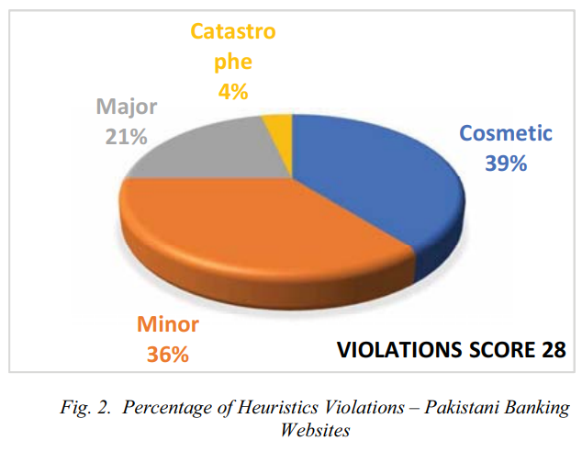

Figure 1: Percentage of Heuristics Violations (Fatima et al., 2020)

In the study conducted by Fatima et al. (2020), an extensive evaluation of online banking websites was performed, employing Jakob Nielsen's 10 Heuristics for User Interface Design and the Web Content Accessibility Guidelines 2.0. The results revealed substantial usability violations in Pakistani Banking Websites, with eight out of ten heuristics being violated, ranging from issues of system visibility to aesthetic design. Notably, 36% of violations were cosmetic, 36% were minor, 21% were major, and 4% were catastrophic, indicating a spectrum of severity. Conversely, International Banking Websites demonstrated superior usability, violating only four heuristics, all with minor or cosmetic severity. Recommendations emphasized improvements in informative system status, user-friendly language, consistent terminology, error prevention, and accessible help. The accessibility evaluation identified common errors in Pakistani websites, contrasting with fewer issues in international banking sites. The results indicate substantial accessibility challenges in Pakistani banking websites, with common errors identified. These issues, such as missing alternative text, low contrast, and keyboard traps, directly impact users with disabilities, hindering their ability to navigate and comprehend the content effectively. The violations of Web Content Accessibility Guidelines suggest that individuals with visual impairments, motor disabilities, or other accessibility needs may face barriers in accessing online financial services. Addressing these accessibility shortcomings is crucial for ensuring an inclusive and equitable user experience, enabling a wider range of users to navigate and interact with banking websites with ease and independence.

Study conducted by Ramakrishnan et al. in 2017 delves into the multifaceted realm of non-visual web browsing, with a primary focus on enhancing accessibility for individuals with visual impairments. Recognizing the pervasive role of the web in daily life, the study underscores the imperative for web developers to ensure inclusivity, referencing the Web Content Accessibility Guidelines as a pivotal guide. The review emphasizes the dominant reliance on Screen Readers for visually impaired users and identifies persistent usability challenges, ranging from information overload to the absence of semantic awareness. The exploration of segmentation-based techniques, including clutter-free browsing, online transaction modelling, and skimming and summarization, reveals strategies aimed at mitigating these challenges and fostering a more user-friendly experience. Additionally, the paper investigates the potential of speech-based browsing and introduces the innovative Web Screen Reading Assistant, driven by a Web Entity Model, as a transformative approach to interaction with web entities. Amidst the evolving landscape of smart devices, the study anticipates future research inquiries into the usability of apps for individuals with vision impairments, encapsulating a comprehensive narrative that underscores the importance of semantic awareness, streamlined navigation, and the reduction of information overload to advance the overall usability of the web for users with visual impairments.

**2.2.2 Text-To-Speech Technology**

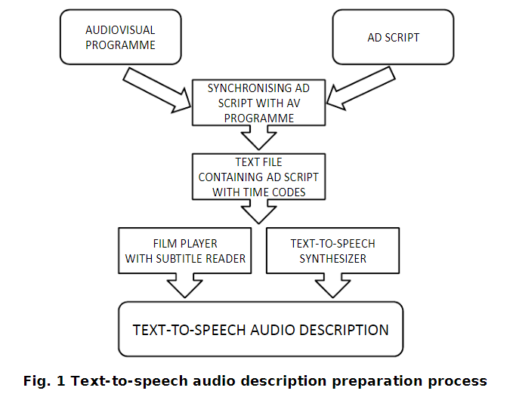

Figure 2: Text-to-Speech Audio Description Preparation Process (Szarkowska, 2011)

In Szarkowska's 2011 research on text-to-speech audio description as an innovative approach to traditional audio description, the study proposed a method where audio description scripts are converted into speech waveforms using speech synthesis software rather than relying on human narrators. This text-to-speech audio description process involves creating audio description scripts, segmenting them with precise time codes, and then utilizing speech synthesis software during film playback. Unlike conventional audio description, which can be limited by complex production processes and restricted distribution, text-to-speech audio description offers a more scalable and cost-effective solution. The text-to-speech audio description method was envisioned as a means to increase the availability of audio-described content, making it more accessible to visually impaired individuals, particularly those residing in areas without regular cinema screenings or live audio description events. The process allows users to enjoy audio-described films independently at home, leveraging their familiarity with speech synthesis software. While text-to-speech audio description does require a degree of media literacy, the study indicated positive attitudes toward the technology, with participants expressing preferences for choosing synthetic voices. The proposed text-to-speech audio description system was positioned not as a replacement for traditional audio description but as a complementary tool to enhance the overall accessibility of audiovisual content for individuals with visual impairments.

Podsiadło and Chahar's 2016 research delves into the nuanced requirements and preferences of visually impaired individuals relying on screen readers and text-to-speech technology. The study reveals that text-to-speech, often considered an auxiliary feature for many users, holds paramount importance for individuals with vision loss, shaping their interactions with digital content. Through a combination of focus groups and individual listening tests, the researchers identified distinct usage patterns, emphasizing the critical role of text-to-speech in both leisure-oriented and factual modes. The findings highlight a preference for lower-pitched, mature-sounding voices with neutral emotional expression, contributing to reduced listening fatigue and enhanced intelligibility. Notably, the study underscores the scarcity of research catering specifically to the needs of visually impaired users in the realm of text-to-speech technology. The researchers address this gap by providing valuable insights into the multifaceted considerations influencing text-to-speech preferences, encompassing factors such as purpose of action, length of text-to-speech experience, and the environment. Overall, the research not only advances our understanding of the unique requirements of visually impaired users but also sheds light on the imperative features for optimizing text-to-speech technology to meet the diverse needs of this user group, offering a comprehensive perspective crucial for future advancements in accessibility-oriented technology development.

Swain and Sahoo's 2021 research sheds light on the transformative role of text-to-speech technology in addressing educational challenges for visually impaired students. The study emphasizes the inadequacies of traditional curricula for sighted learners and underscores the pivotal role of text-to-speech in making visually complex scientific concepts accessible to the visually impaired. While the focus is on education, the broader implications of this research extend to various industries, including the banking sector. The use of text-to-speech in educational applications highlights its potential for enhancing accessibility in diverse contexts. In the banking industry, integrating text-to-speech into digital interfaces could significantly improve accessibility for visually impaired customers. Similar to the VI Learner application, a customized banking application could leverage text-to-speech as a foundational approach to provide audio-based information on account details, transaction history, and other financial services. This adaptation aligns with the inclusive ethos advocated by Swain and Sahoo, ensuring that visually impaired individuals can independently access essential banking services. Furthermore, the anticipation of future developments, such as the addition of a speech-to-text feature, suggests a dynamic approach that could further enhance user interaction in the banking realm. Overall, the insights from Swain and Sahoo's research provide a valuable foundation for considering text-to-speech solutions in the banking industry.

**2.2.3 Security Protocols in Online Financial Services**

In the research conducted by Ronchi et al. in 2011, the investigation centers on the pervasive insecurity characterizing Internet transactions, with a specific focus on Internet banking. The study underscores the role of end users in the security landscape, emphasizing the common challenge where theoretically robust security measures face undermining due to user behavior. The prevalent solution involving the isolation of security-critical elements from end-user devices is subject to critical examination. The paper delves into the principles and practices of Internet banking, considering the estimated number of users and the susceptibility of their devices to attacks. A holistic approach to security is advocated, acknowledging physical cracking, social engineering, and malicious software as interconnected attack vectors. A key point of contention is whether the primary design principle for Internet banking systems should solely be the prevention of financial fraud, or if equal emphasis should be placed on protecting end users' privacy and preventing identity theft. The paper critiques after-systems that detect fraud post-transaction, asserting their inadequacy in addressing key parameters like transaction efficiency. The proposed Attack Vector Activity Analysis (AVAA) metric is applied to evaluate security systems, including disconnected and connected devices and hardened web browsers. The study concludes by urging banks to prioritize end-user privacy, lower hacking return on investment, simplify usability, and maintain transparent communication with users about security risks.

Ahmed et al.'s 2015 research in the realm of security protocol privacy for accessibility places a noteworthy emphasis on computing privacy concerns and the security of computing devices for visually impaired individuals. The study delves into the challenges faced by participants in maintaining the privacy of their digital interactions. Key findings underscore the participants' awareness of visual eavesdropping risks, particularly in public spaces, leading to self-imposed limitations on device use. The research sheds light on the struggles with password management among visually impaired users, revealing practices such as recording passwords in computer files, which, though aiding accessibility, pose concerns about potential aural eavesdropping. Furthermore, the study highlights skepticism and challenges regarding the use of password manager software among participants. The research by Ahmed et al. provides critical insights into the security vulnerabilities specific to visually impaired individuals, including their susceptibility to hacking and difficulties in discerning security cues in web browsers. The study not only identifies these concerns but also emphasizes the need for more accessible security features, addressing the limitations faced by visually impaired users in ensuring the security of their computing devices. In doing so, Ahmed et al. contribute significantly to the literature on security protocols and privacy considerations in the context of accessibility for individuals with visual impairments.

In Napoli's (2018) research on accessible and usable security, the focus centers on visually impaired users' online security and privacy strategies. The literature review underscores the significance of addressing the unique challenges faced by visually impaired individuals in navigating security and privacy threats while browsing the web. Napoli emphasizes the field of usable security, emphasizing the need to integrate user behaviors into the design of security mechanisms to mitigate the severity of threats. The discussion delves into key security and privacy threats encountered during web browsing, such as password hacking, phishing, man-in-the-middle attacks, and malicious software. Design guidelines and frameworks proposed by Garfinkel and Lipford (2014) are highlighted, advocating for reducing security responsibility on users, enabling secure defaults, providing clear instructions, describing security contexts, and promoting user training in best practices. The review further explores the application of usable security principles, including visual representations of security indicators within browser chrome and novel solutions tailored to visually impaired users, such as accessible password managers and observation-resistant password schemes. Napoli identifies gaps in existing literature, noting the limited exploration of non-visual security mechanisms for visually impaired users, emphasizing the need for broader research to address this underserved population's specific usability and accessibility challenges in the realm of online security and privacy.

## 2.3 Similar Systems

**2.3.1 Barclays**

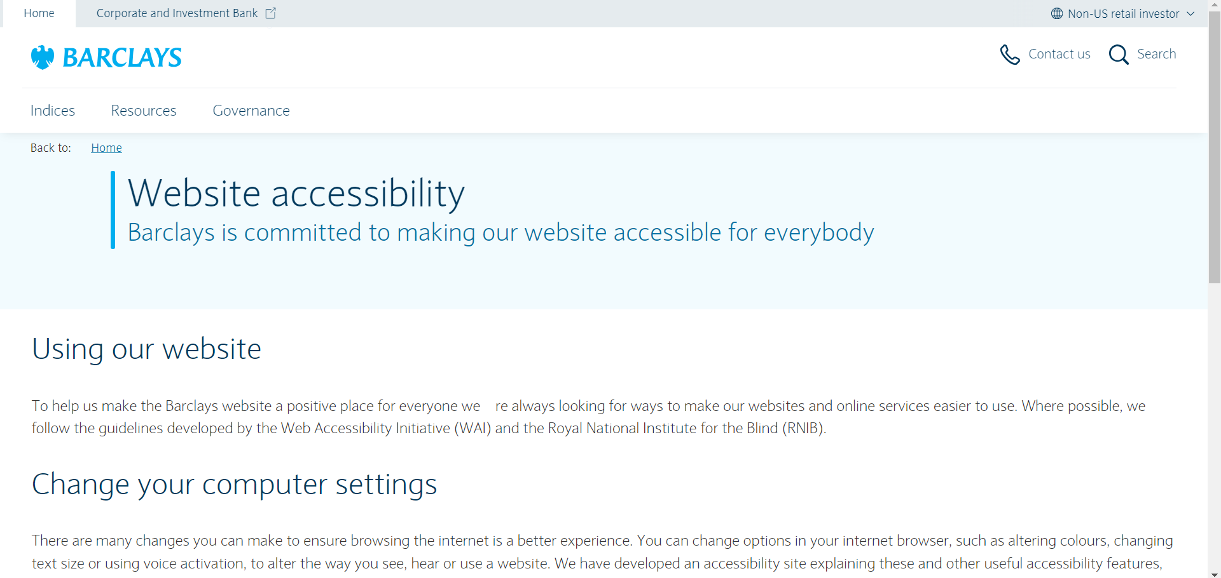

Figure 3: Barclays' website (Barclays, n.d.)

Barclays, as a financial institution, demonstrates a strong commitment to digital inclusivity and accessibility for individuals with visual impairments (Barclays, n.d.). The bank prioritizes compatibility with screen readers, crucial tools for the visually impaired, in line with industry standards and legal requirements. They enhance visibility through high contrast color schemes and distinct color choices while also providing alternative text for images to ensure a comprehensive user experience. In addition to supporting keyboard navigation, Barclays could further improve online form accessibility by offering clearer instructions and feedback for users relying on assistive technologies.

Strengths:

* Strong compatibility with screen readers.
* High contrast color schemes and distinct color choices.
* Support for keyboard navigation.

Weaknesses:

* Online forms may need clearer instructions and feedback for users with visual impairments.

**2.3.2 BBC**

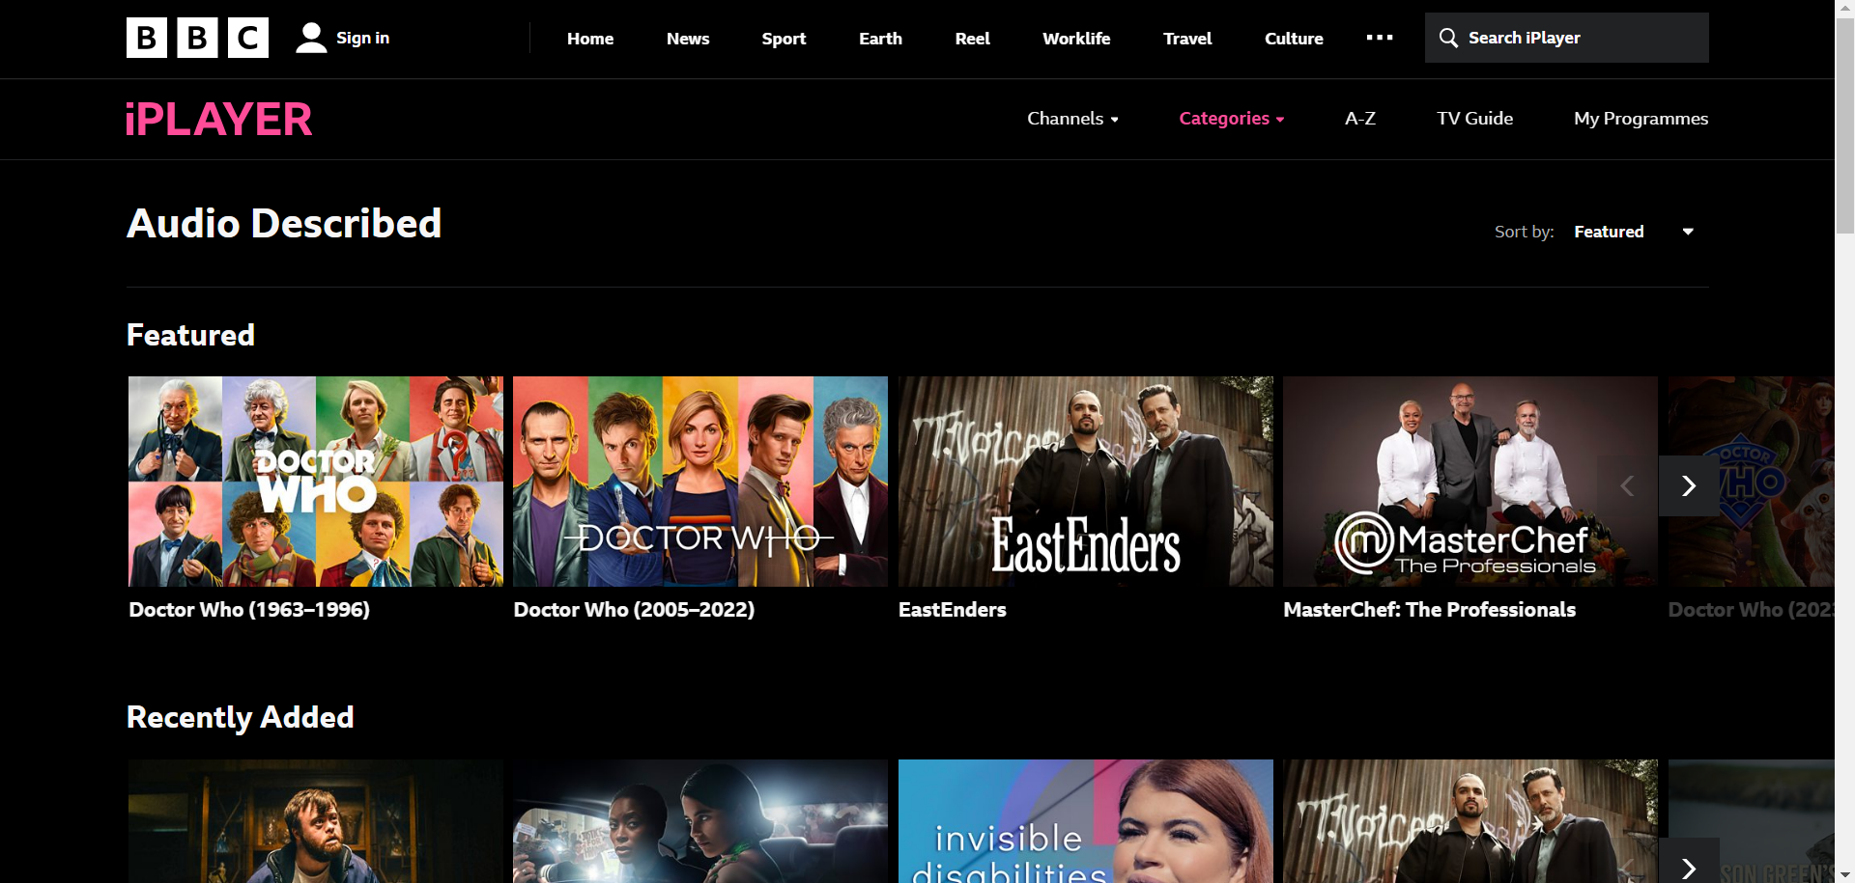

Figure 4: BBC iPlayer website (BBC, n.d.)

The BBC is well-known for its dedication to inclusivity and has taken significant steps to improve accessibility, especially for those with visual impairments. This includes offering audio description services for a wide variety of programs and using subtitles and closed captioning extensively. The use of high contrast, easily readable fonts, and clear typography in the website's design is praiseworthy. Additionally, responsive design principles ensure a consistent experience across different devices. However, ongoing user feedback and testing show a commitment to improvement despite occasional inconsistencies or areas that could be enhanced.nconsistencies or areas for enhancement.

Strengths:

* Comprehensive audio description services.
* Extensive use of subtitling and closed captioning.
* Prioritization of high contrast and clear typography.

Weaknesses:

* Difficult to set up accessibility features.

**2.3.3 Bank of America**

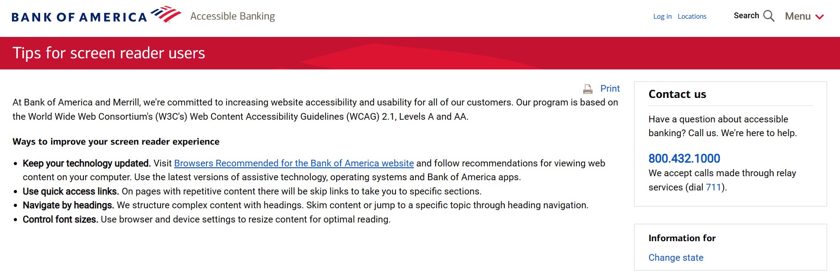

Figure 5: Bank of America Website (Bank of America, n.d.)

Bank of America is recognized as one of the leading international financial firms with a strong dedication to delivering comprehensive banking services. The bank guarantees excellent support for screen readers and provides easily accessible online statements, demonstrating a commitment to making financial information readily available to users with varying abilities. Customizing customer support services for inclusivity is a noteworthy advantage. Offering a " Tips for screen reader users" page serves as a valuable tool that empowers individuals who are visually impaired. However, providing more transparency about the regularity of updates to accessibility features would contribute further in boosting user assurance.

Strengths:

* Strong compatibility with screen readers.
* Accessible online statements.
* Quick access links.

Weaknesses:

* Website frequent updates.

**2.3.4 Comparison**

|  |  |  |  |  |
| --- | --- | --- | --- | --- |
| **Features** | **Barclays** | **BBC** | **Bank of America** | **FinEase (Proposed System)** |
| Built in Text-to-Speech | X | X | X | ✓ |
| Selective Reading | X | X | X | ✓ |
| Compatible with External Assistive Tools | ✓ | ✓ | ✓ | X |
| Contrast and Color Choices | ✓ | ✓ | ✓ | ✓ |
| Alternative Text for Images | ✓ | ✓ | ✓ | ✓ |
| Guided Navigation | X | X | X | ✓ |
| Keyboard Navigation | ✓ | X | X | ✓ |
| Accessible Statements | ✓ | X | ✓ | ✓ |
| Customization | ✓ | ✓ | ✓ | ✓ |
| Audio Description | X | ✓ | X | ✓ |
| Quick Accessibility Link | X | X | X | ✓ |

Summary here. Justify why proposed system this and that

## 2.4 Technical Research

### 2.4.1 Hardware

Audio Output Devices: For testing and experiencing the text-to-speech functionality, standard audio output devices such as headphones or speakers are essential. These devices ensure that developers can accurately assess the quality and performance of the text-to-speech system in various scenarios.

### 2.4.2 Programming Languages

**2.4.2.1 Java**

Java is recognized for its platform independence and "Write Once, Run Anywhere" concept, enabling applications to be executed on any device with a Java Virtual Machine (AWS, n.d.).

**IDE:** NetBeans

**Library:** FreeTTS (Free Text-to-Speech): An open-source, Java-based speech synthesis system. It provides a platform-independent and customizable solution for text-to-speech functionality within Java applications.

**Pros:**

* Platform Independence: Java's allows the application to run on any device with a Java Virtual Machine (JVM).
* Extensive Libraries: Java has a rich set of libraries, including FreeTTS, making it suitable for various applications.
* Strong Community Support: Java has a large and active community, providing ample resources and support.

**Cons:**

* Verbosity: Java code tends to be more verbose compared to languages like Python, which can lead to longer development times.
* Memory Consumption: Java applications might consume more memory compared to some other languages.

**2.4.2.2 Python**

Python is recognized as a high-level and interpreted coding language celebrated for its clearness and user-friendly nature. It prioritizes code readability and enables developers to articulate ideas using fewer lines compared to languages such as Java or C++ (Corbo, 2022).

**IDE:** Visual Studio Code

**Library:** gTTS (Google Text-to-Speech): A Python library that interfaces with Google Translate's text-to-speech API. It allows developers to integrate Google's powerful text-to-speech capabilities into Python applications.

**Pros:**

* Readability: Python's syntax is clear and readable, making it an excellent choice for beginners and projects with a focus on readability.
* Large Ecosystem: Python has a vast ecosystem of libraries and frameworks, including gTTS for text-to-speech functionality.
* Rapid Development: Python's concise syntax often leads to faster development.

**Cons:**

* Global Interpreter Lock (GIL): Python has a GIL that can limit the execution of multiple threads, impacting performance in multithreaded applications.
* Mobile Development: Python is not as commonly used for mobile app development as some other languages.

**2.4.2.3 JavaScript**

JavaScript is a programming language mainly utilized for constructing dynamic content on the internet. It plays a crucial role in front-end web development, empowering developers to generate engaging and adaptable user interfaces. JavaScript operates on the client side, ensuring compatibility with web browsers (MDN Contributors, 2019).

**IDE:** Visual Studio Code

**Library:** Web Speech API: A browser-based API that facilitates speech synthesis in modern browsers. It enables developers to incorporate text-to-speech functionality directly into web applications.

**Pros:**

* Full-Stack Development: JavaScript is versatile, allowing developers to work on both the client and server sides (Node.js).
* Web Compatibility: JavaScript is the language of the web, ensuring compatibility with browsers.
* Vibrant Ecosystem: A vast array of libraries and frameworks, including the Web Speech API, is available for JavaScript.

**Cons:**

* Asynchronous Programming: Asynchronous code (callbacks, promises) can be challenging for beginners.
* Security: Being executed on the client side, JavaScript code is visible to users, raising security concerns.

### 2.4.3 Operating System

**2.4.3.1 Windows**

Windows, created by Microsoft, is a popular line of graphical operating systems that offers an intuitive interface for personal computers. With functionalities like a graphical user interface, taskbar, and file system, Windows provides users with the ability to manage data and run different applications using standard input devices. It has released various versions, including Windows 95, XP, 7, 8, 10 and 11. Windows is widely embraced across households, businesses, and industries alike; Windows continues to serve as a fundamental element in personal computing by providing a flexible and accessible platform for users globally (Computer Hope, 2019).

**Pros:**

* Development Tools: Windows has strong support for a wide range of development tools and IDEs.
* User-Friendly: If your development team is more familiar with Windows environments, it might enhance productivity.

**Cons:**

* Resource Consumption: Windows environments might consume more resources compared to Linux.

**2.4.3.2 Linux**

Linux, an open-source kernel with similarities to Unix, is the basis of multiple Linux distributions. Developed collaboratively by a global community of developers, it is renowned for its stability, security, and adaptability. From servers and mainframes to desktop computers and embedded systems, Linux covers a wide range of devices. Popular distributions like Ubuntu, Fedora, and Debian bundle the Linux kernel with added software and a customizable desktop environment to create complete operating systems. Linux's open nature allows users to freely modify and distribute it, contributing to a large ecosystem of free and open-source software. In result, Linux has been widely embraced in server environments and has played a pivotal role across various computing domains, including embedded systems, cloud computing, and mobile devices (Loshin & Bigelow, 2021).

**Pros:**

* Open Source: Linux is open source, providing flexibility for customization and development.
* Stability: Known for its stability, Linux can be a reliable choice for server-side components.

**Cons:**

* Compatibility: Some software may have better support for Windows or Mac OS.

### 2.4.4 Web Server

#### 2.4.4.1 Apache Tomcat

Apache Tomcat, created by the Apache Software Foundation, is an open-source application server that has been specifically designed for the execution of Java Servlets and JavaServer Pages. It offers a strong and adaptable platform for running Java web applications, making it essential for developers working on projects based on Java. Serving as a servlet container, Tomcat oversees the execution of Java servlets and simplifies the deployment process for these web applications (Pomponio, 2022).

**Pros:**

* Open-source and widely used.
* Good documentation and community support.
* Supports Java-based web applications.

**Cons:**

* Configuration may be complex for beginners.
* Requires Java knowledge for advanced customization.

#### 2.4.4.1 Nginx

Nginx is widely recognized as a high-performance, open-source web server and reverse proxy. Its capability to efficiently serve static content and function as a reverse proxy sets it apart. Particularly adept at directing client requests to other servers or applications, Nginx plays a vital role in contemporary web architectures. It is commonly deployed ahead of application servers for load balancing, SSL termination, and caching purposes due to its efficiency in managing numerous concurrent connections while consuming minimal resources (Pomponio, 2022).

Pros:

* High-performance web server.
* Efficient resource usage.
* Good for serving static content.

Cons:

* Less suitable for dynamic content (compared to Apache).
* Advanced configurations might be challenging.

### 2.4.5 Web browser

#### 2.4.5.1 Google Chrome

Google Chrome, developed by Google in 2008, has gained popularity due to its speed, simplicity, and integration with various Google services. It is distinguished by a minimalist design, fast rendering engine, and a wide range of extensions. The browser is recognized for its efficient performance, security features, and ability to synchronize across devices (Valeria, 2023).

**Pros:**

* Widely used, extensive developer tools.
* Good performance and compatibility.

**Cons:**

* Owned by Google, which may be a concern for privacy-minded users.

#### 2.4.5.2 Microsoft Edge

Microsoft Edge, launched in 2015 to replace Internet Explorer as a web browser developed by Microsoft, has become the default Windows 10 browser and is now also accessible on macOS, Android, and iOS. Based on the Chromium engine used by Google Chrome, this transition has enhanced Edge's speed, adaptability, and adherence to web protocols. Among its various features are customizable start page options and integrated Cortana support for distraction-free reading with focus mode (Valeria, 2023).

**Pros:**

* Chromium-based, improving compatibility.
* Integration with Windows features.

**Cons:**

* Some users may prefer full Chromium without Microsoft integrations.

#### 2.4.5.3 Mozilla Firefox

Mozilla Firefox, often referred to as Firefox, is a web browser developed by the Mozilla Foundation. It has a rich history as one of the earliest alternatives to Internet Explorer and prioritizes speed, privacy, and customization. The browser places strong emphasis on user privacy through tracking protection and enhanced privacy settings while also offering support for various add-ons and themes for personalized browsing experiences (Valeria, 2023).

**Pros:**

* Open-source and privacy-focused.
* Robust developer tools.

**Cons:**

* Slightly lower performance in some cases.

## 2.5 Summary

The literature review delves into the intersection of accessibility, technology, and security in online financial services. It scrutinizes challenges faced by visually impaired users, usability violations in banking websites, and innovations in Text-to-Speech (TTS) technology. Studies emphasize adherence to accessibility guidelines, improvements in system status, and user-friendly language. Non-visual web browsing techniques, including segmentation-based approaches, are explored. TTS technology is investigated for its potential to increase audio-described content availability and cater to visually impaired users' distinct preferences. Security protocols in Internet banking are analyzed, urging a holistic approach prioritizing end-user privacy. The review concludes with a comparative analysis of similar systems, spotlighting strengths and weaknesses in Barclays, BBC, and Bank of America, with a focus on compatibility with screen readers and the usability of online platforms. In addition, the review incorporates a detailed discussion of technical research, including hardware requirements, programming languages such as Java, Python, and JavaScript, and considerations for operating systems, web servers, and web browsers.

# Chapter 3: Methodology

## 3.1 Introduction

A System Development Method is a structured and methodical approach used in creating information systems, software, or applications. It provides a comprehensive framework with guidelines, processes, and tools to facilitate the entire development lifecycle. The main aim of an system development method is to ensure that the development process is well-organized, effective, and in line with the project's objectives (Saravanan, 2017). The choice of a particular system development method depends on factors such as project complexity, organizational preferences, and required flexibility. Each system development method has its own strengths and weaknesses which influence the selection based on the unique characteristics and needs of each specific project.

## 3.2 Agile Methodology

Agile methodology is a flexible and iterative approach to system development, placing importance on flexibility and teamwork (vpadmin, 2023). Unlike traditional methods such as Waterfall, Agile does not follow a linear sequence of phases but instead utilizes short development cycles called sprints. These sprints involve the continuous development, testing, and delivery of small increments of a project. This iterative approach allows for ongoing reassessment and adaptation, enabling quick responses to changing requirements and stakeholder feedback. Agile prioritizes customer satisfaction by emphasizing early and continuous delivery of valuable software. It encourages collaboration among multidisciplinary teams and welcomes changes throughout the development process. Agile principles, as delineated in the Agile Manifesto, highlight the significance of personal interactions and collaboration, prioritizing functional deliverables over excessive documentation, adapting to change, and customer engagement. This methodology is especially suitable for endeavors that require adaptability and ongoing enhancement.

## 3.3 Waterfall Methodology

The Waterfall Model is a well-known example of a system development method, identified by its linear and sequential progression through distinct development phases. In this model, each phase must be completed before moving on to the next, providing a structured and well-defined path from initiation to deployment (vpadmin, 2023). The Waterfall methodology functions as an application development tool, flowing through the different stages of a project in a sequential manner, similar to that of a waterfall. However, it may encounter difficulties in accommodating changes once a phase has begun, making it more suitable for projects with clearly defined requirements.

## 3.4 Methodology Choice and Justification

Table 1: Comparison between Agile Methodology and Waterfall Methodology

|  |  |  |
| --- | --- | --- |
| **Criteria** | **Agile Methodology** | **Waterfall Methodology** |
| **Adaptability and Flexibility** | Agile offers great adaptability, allowing for changes even in the later stages of development. | Waterfall is inflexible, following a sequential process that necessitates finishing each stage before proceeding. Adapting to changes during the project can be difficult. |
| **Client Collaboration** | Agile prioritize continuous client collaboration throughout the development process to ensure regular feedback loops and alignment with changing client needs. | Waterfall primarily involves obtaining client feedback at the beginning and end, which may result in discrepancies between the final product and client expectations. |
| **Iterative Development** | Agile follows a cyclic approach with sprints, delivering smaller, incremental project updates at regular intervals. | Waterfall follows a linear progression, completing each phase fully before advancing, resulting in longer wait times for the final product. |

The project selection of the **Scrum framework** is carefully justified by the adoption of **Agile methodology**. This decision is based on the adaptability inherent in Agile, which enables dynamic adjustments during development which is a crucial factor for a project with evolving requirements and uncertainties. The inflexible nature of the Waterfall model is recognized, underscoring the necessity for flexibility, particularly in accommodating changes later in the project's lifecycle.

Scrum, a component of the Agile methodology, distinguishes itself through its strong focus on continual client involvement. Its iterative development method with short cycles closely matches the project's need for prompt and concrete results. The consistent delivery of smaller project segments in Scrum supports a responsive and customer-focused development process. This strategy encourages continuous stakeholder participation, offers regular progress updates, enhances communication effectiveness, and reduces the chances of discrepancies between delivered outcomes and client requirements (Sergeev, 2020).

In summary, Scrum, as a part of the Agile framework, is deliberately chosen for its adaptability to changing requirements, its emphasis on continuous client collaboration, and its iterative development approach. These characteristics collectively make Scrum the ideal choice for a project where flexibility, client engagement, and the timely delivery of tangible results are paramount to success.

## 3.5 Stages of Scrum Framework

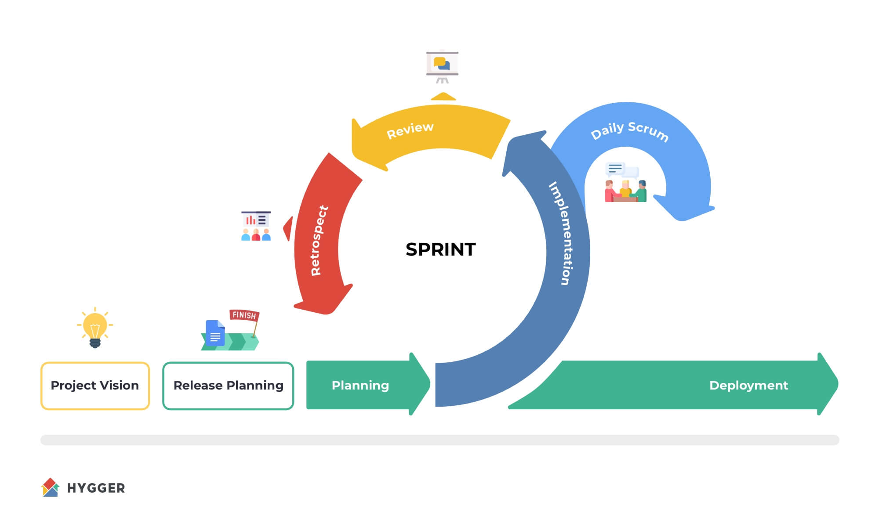

Figure 6: Scrum Lifecycle (Sergeev, 2020)

**Stage 1: Planning**

* The Product Owner identifies the need for financial accessibility for the visually impaired.
* Define challenges faced by visually impaired users in online financial services.
* Establish the vision and goals for the project to enhance financial inclusivity.

**Stage 2: Inception**

* Form a cross-functional team including developers, designers, accessibility specialists, and domain experts.
* Define overall project goals, scope, and objectives during the initial sprint.
* Create a product backlog prioritizing features for financial accessibility.

**Stage 3: Iteration**

1. Sprint Planning:

* Conduct detailed sprint planning meetings.
* Breakdown prioritized features into tasks for short development cycles or sprints.

1. Development:
   * Implements the integration of Text-to-Speech technology, develops features for real-time auditory feedback, navigation aid, and Text-to-Speech for PDF documents within short development cycles or sprints.
2. Testing:

* Conduct thorough testing of implemented features within each sprint.

1. Sprint Review and Demo:

* Complete and deliver increments of the product at the end of each sprint.
* Showcase implemented features to stakeholders, including visually impaired users.

1. Sprint Retrospective:

* Gather feedback from stakeholders and users.
* Iterate on features based on feedback, addressing usability issues and improving accessibility.

**Stage 4: Testing**

* Conduct comprehensive testing of the entire system, ensuring the stability and effectiveness of all accessibility features.
* Perform user acceptance testing with visually impaired users to validate the accessibility improvements.

**Stage 5: Production**

* Release increments of the product at the end of multiple sprints.
* Ensure that visually impaired users experience regular and tangible improvements.
* Incorporate user feedback iteratively to enhance features and meet evolving accessibility needs.

**Stage 6: Review**

* Continuously refine the product backlog based on changing requirements.
* Address emerging challenges and usability issues.
* Optimize the development process based on lessons learned from previous sprints.

**Stage 7: Retirement**

* Evaluate the overall success of the project in enhancing financial accessibility.
* Document lessons learned and best practices.
* Consider future improvements or additional features based on user feedback and changing needs.

## 3.6 Data Gathering

To gather data for this investigation, a survey methodology has been selected as the main method of information collection. Surveys are ideal for efficiently capturing various participant perspectives and providing quantitative data on user preferences, experiences, and opinions. The structured format of surveys enables standardized data collection, making it easier to analyze and interpret the gathered information systematically.

Upon entering the survey form, the participants of the survey are welcome to take part in the study with a brief explanation of its purpose and assurance that their responses will be kept confidential.

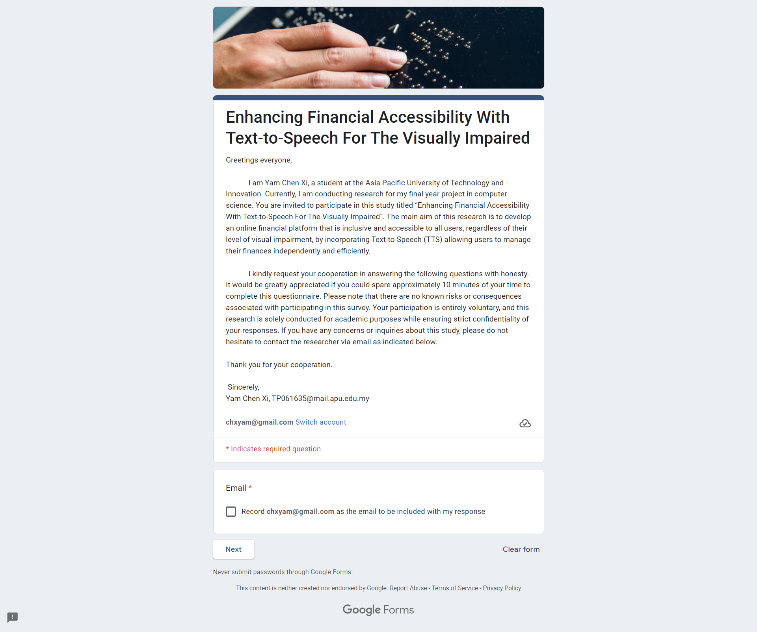

Figure 7: Survey welcome page

The attached **Information Sheet** to the survey provides an outline of the project's goals. Participants are notified about the gathering of demographic data and assured that their information will be kept confidential. Participants’ honest feedback is welcome to improve the system, and participant anonymity will be safeguarded during the study. Participants are reminded to obtain guardian supervision for the Online Finance Accessibility Study.

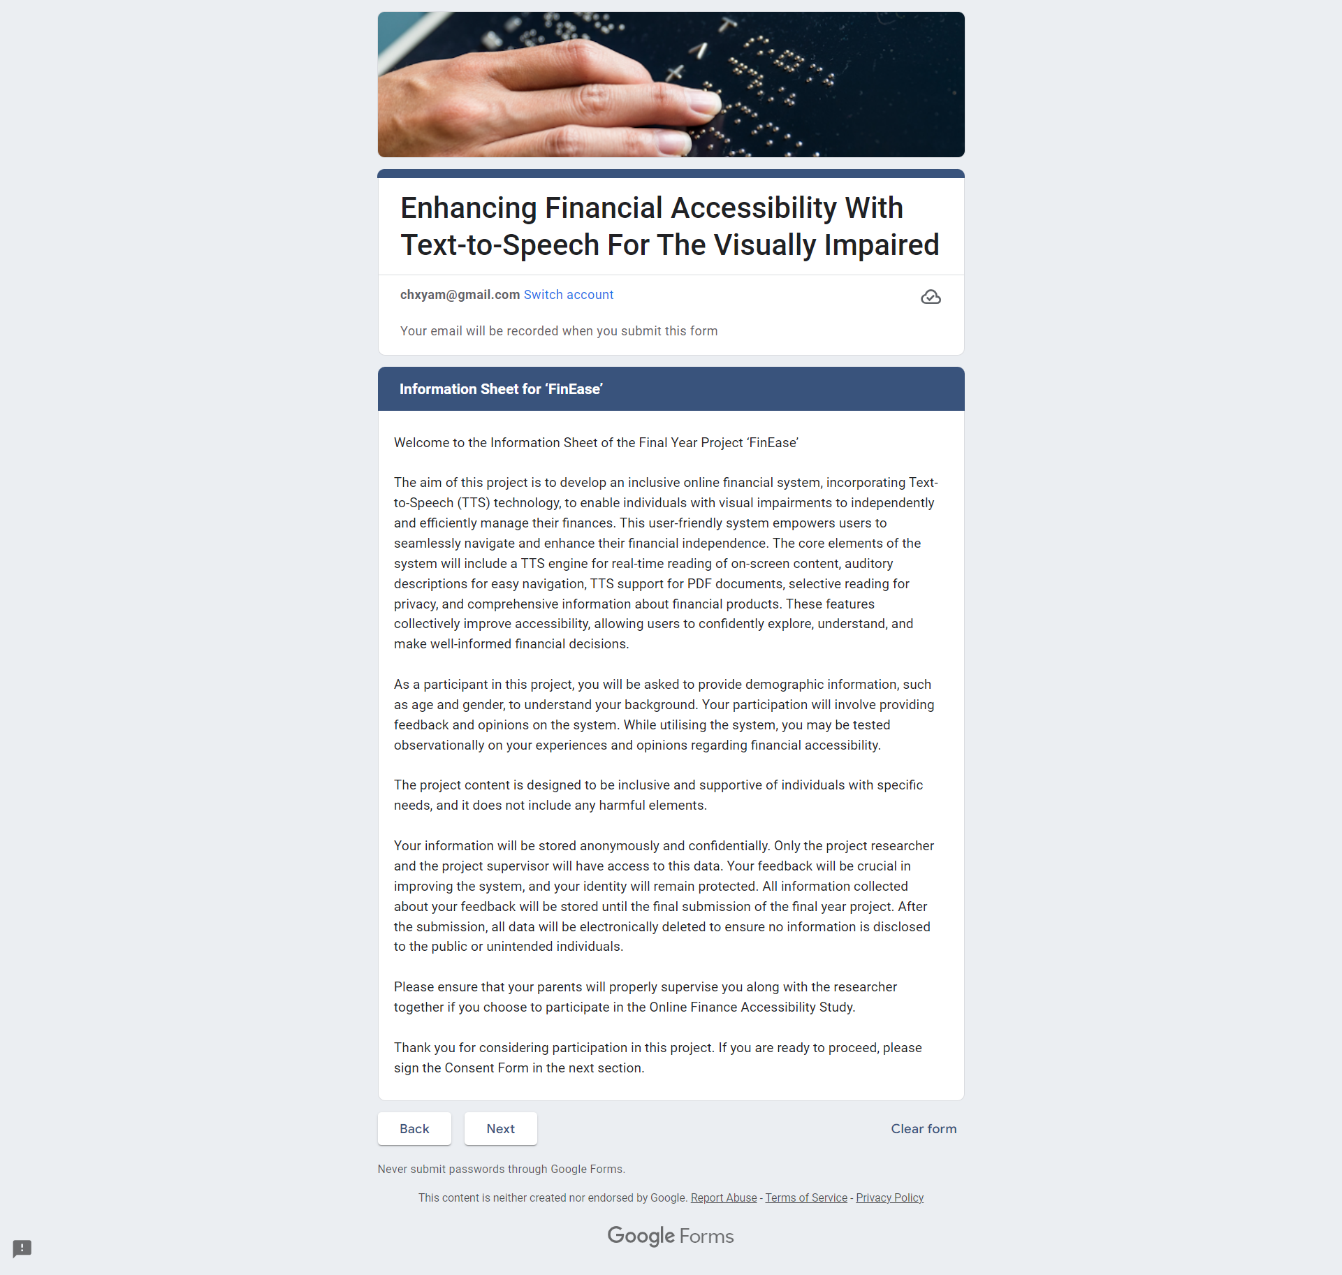

Figure 8: Survey Information Sheet

After reviewing the information sheet and agreeing to participate in the survey, participants are presented with a **Consent Form** that must be signed before they can proceed to complete the questionnaire.

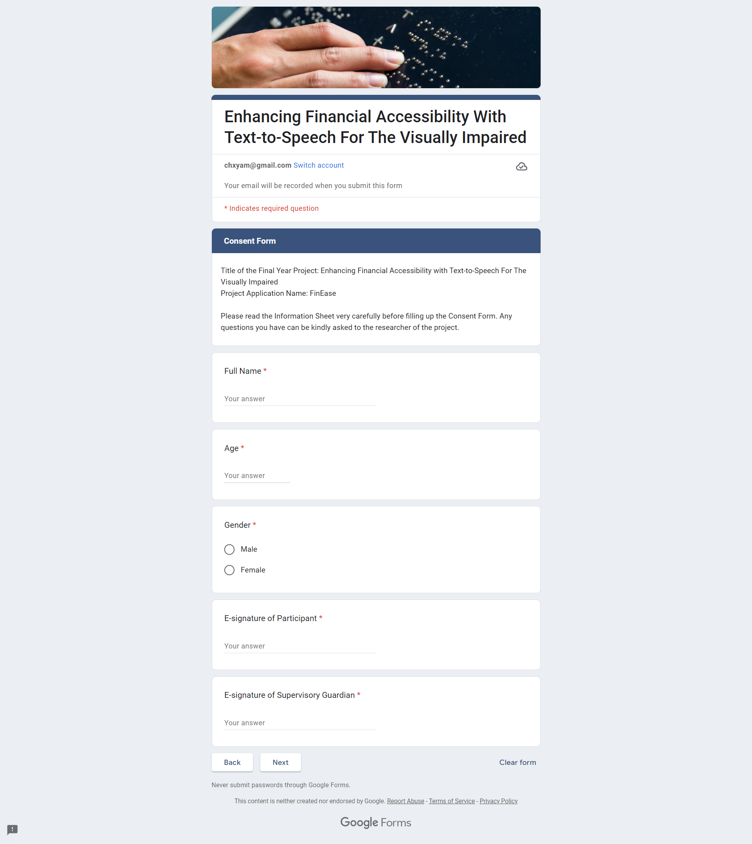

Figure 9: Survey Consent Form

**Section A** of the survey is designed to collect essential demographic information from participants. This includes details such as nationality, level of education, employment status and visual condition. By gathering this comprehensive data about participants' backgrounds and characteristics, researchers can gain a deeper insight into their perspectives and experiences throughout the remainder of the survey.



Figure 10: Survey Section A

**Section B** of the survey focused on gathering data about user preferences for accessibility in online financial platforms. With 15 questions, this segment aimed to explore participants' experiences and expectations regarding accessibility features. Questions 1-13 utilized a Likert-scale format. while **open-ended questions 14 and 15** allowed participants to provide qualitative insights. This structured survey approach was chosen for its efficiency in collecting valuable data that will inform further investigation stages. Below are the questions attached in the survey.

**5-point Likert scale questions (1 = Strongly Disagree, 5 = Strongly Agree)**

**Q1:** I am aware of the available external assistive technologies for accessing online platforms.

**Q2:** I believe that online financial platforms should prioritize accessibility improvements for users with disabilities.

**Q3:** I prefer to independently manage my financial affairs.

**Q4:** I am satisfied with the current accessibility features provided by online financial platforms for users.

**Q5:** I have encountered difficulties when accessing financial information or services online alone.

**Q6:** I often navigate online financial platforms using external assistive tools.

**Q7:** I have experienced compatibility challenges when using external assistive tools on online financial platforms.

**Q8:** I have privacy concerns when using external assistive tools.

**Q9:** I face challenges when adapting to frequent new updates of the online financial platform.

**Q10:** I am willing to switch to a more accessible online financial platform if available.

**Q11:** I have a positive perception of adapting internal assistive technologies built into online financial platforms.

**Q12:** I agree that technology like FinEase can contribute to achieving SDG 10 (Reduce inequality).

**Q13:** I am confident that the adoption of FinEase can significantly improve financial inclusivity.

**Open Ended Questions**

**Q14:** What do you consider the most significant challenges in accessing financial information online today?

**Q15:** What specific accessibility features do you believe are most crucial for online financial platforms to have for users with visual impairments?

## 3.7 Analysis

### 3.7.1 Section A: Background of Respondent

**Age**

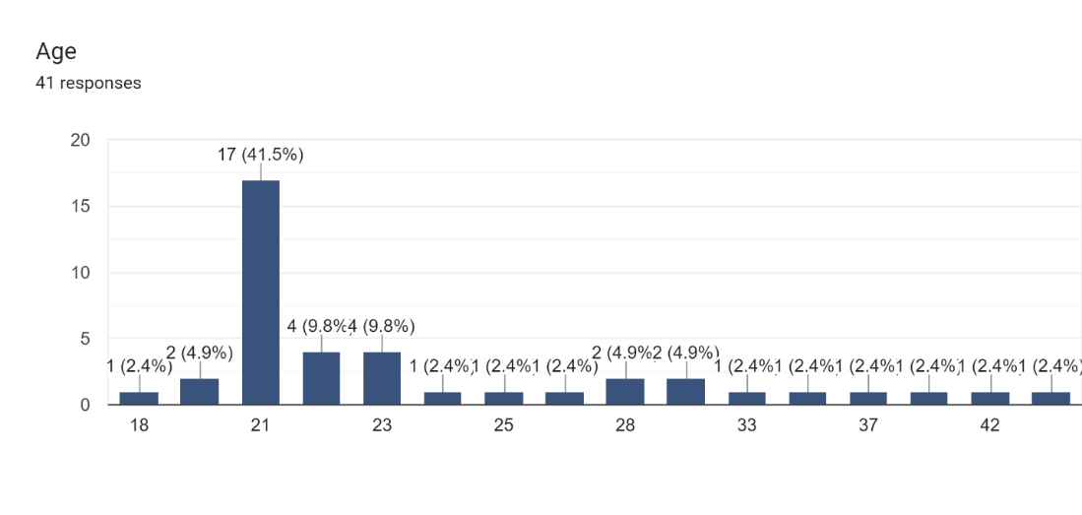

Figure 11: Survey Respondent Age Chart

The most common age range for survey respondents was 21 to 23, with the largest proportion of respondents being aged 21 at 41.5%.

**Gender**

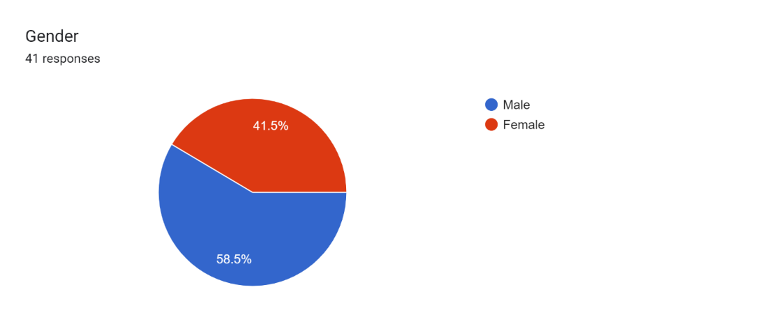

Figure 12:Survey Respondent Gender Chart

The survey respondents are distributed as 58.5% male and 41.5% female, respectively.

**Nationality**

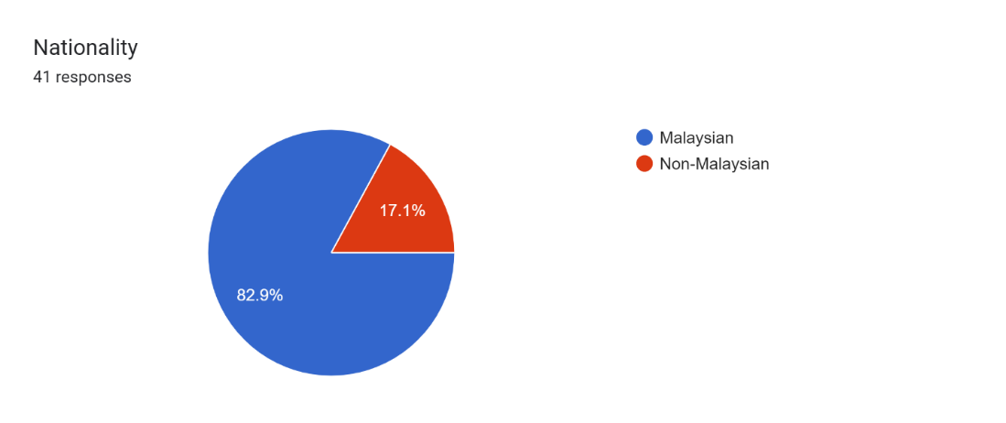

Figure 13: Survey Respondent Nationality Chart

The survey participants are distributed with 82.9% being Malaysian and 17.1% Non-Malaysian.

**Current Education Level**

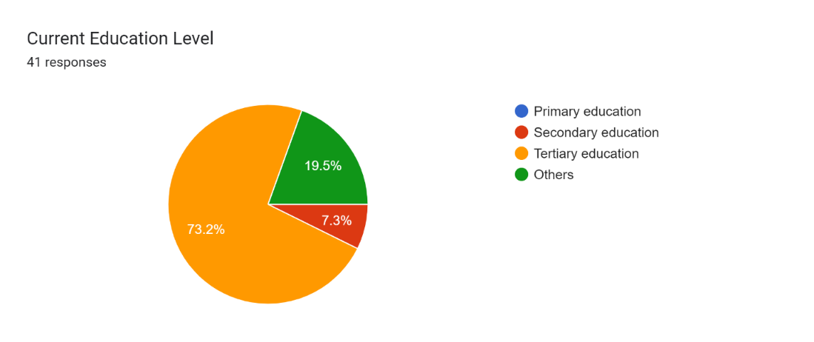

Figure 14: Survey Respondent Current Educational Level Chart

There are 73.2% of survey respondents who have completed tertiary education, 19.5% possess other types of education, and 7.3% have completed secondary education levels.

**Employment Status**

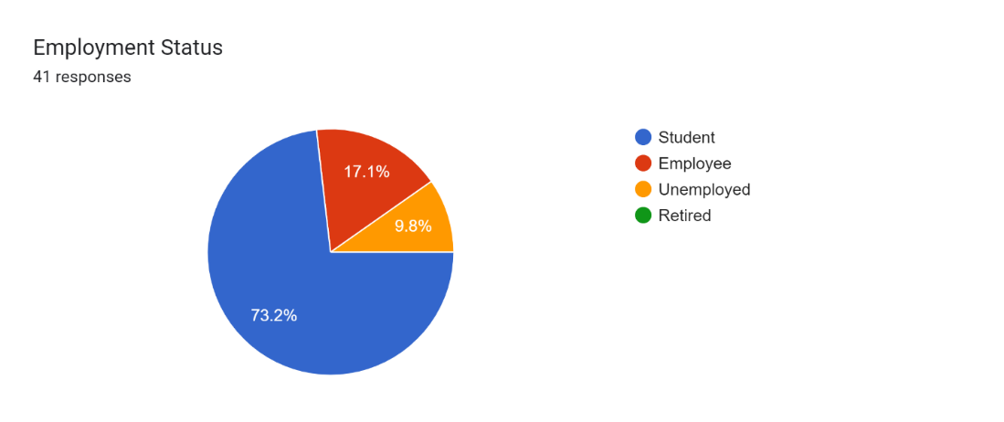

Figure 15: Survey Respondent Employment Status Chart

Employment status of the survey respondents: 73.2% are students, 17.1% are employed, and 9.8% are unemployed.

**Vision Condition**

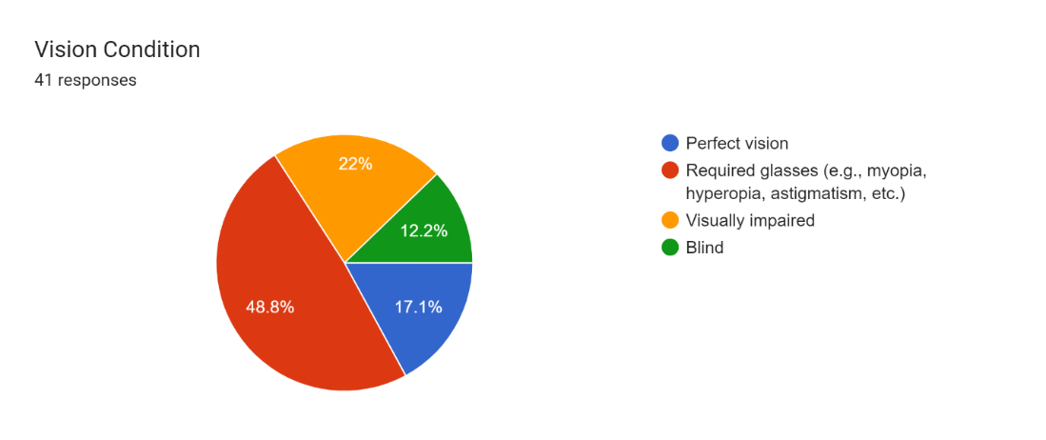

Figure 16: Survey Respondent Vision Condition Chart

The majority of survey respondents at 48.8% required glasses for daily life, followed by visually impaired individuals at 22% and blind individuals at 12.2%.

### 3.7.2 Section B: Accessibility and User Preferences

**Question 1: I am aware of the available external assistive technologies for accessing online platforms.**

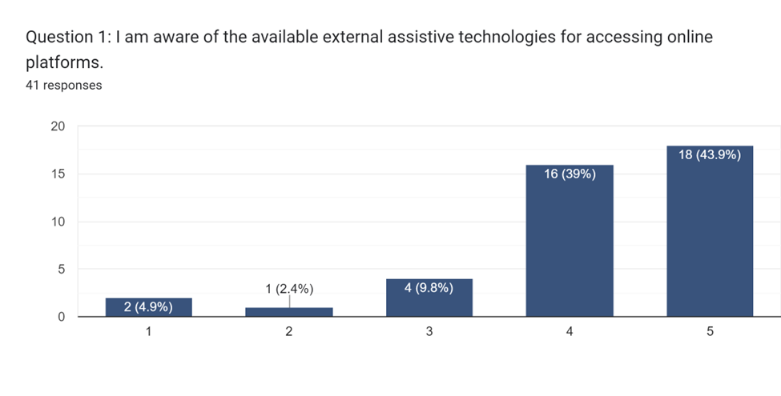

Figure 17: Survey Section B Q1 Result

Regarding awareness of the availability of external assistive technologies, a significant proportion of the survey respondents, amounting to 43.9%, rated their awareness as 5 on a scale of 1 to 5. This indicates a high level of awareness among a substantial segment of the participants.

**Question 2: I believe that online financial platforms should prioritize accessibility improvements for users with disabilities.**

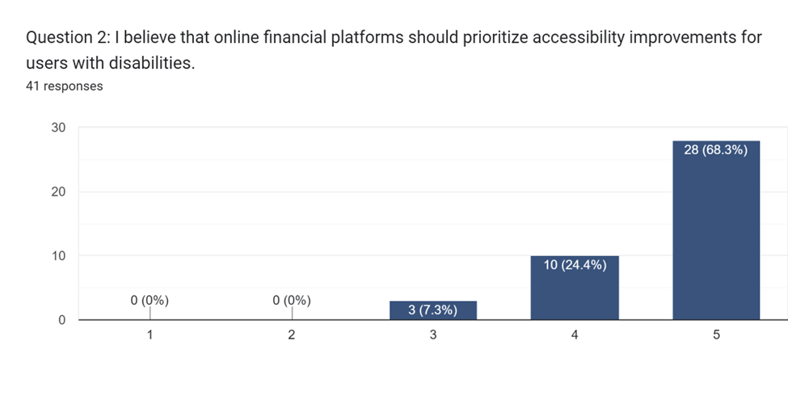

Figure 18: Survey Section B Q2 Result

Question 2 garnered a notable 68.3% of respondents rating 5 out of 5, indicating a strong belief in prioritizing accessibility improvements for users with disabilities on online financial platforms. This likely reflects a growing societal awareness of inclusivity in digital services and the perceived positive impact on creating a more diverse and accessible online financial landscape.

**Question 3: I prefer to independently manage my financial affairs.**

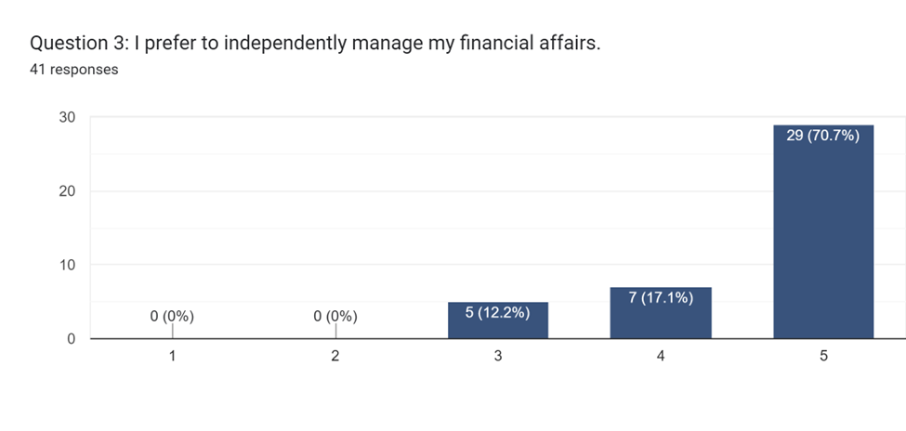

Figure 19: Survey Section B Q3 Result

Question 3 reveals a substantial preference for independent financial management, with 70.7% of respondents giving a top rating of 5. This high percentage suggests a strong desire among participants to autonomously handle their financial affairs, emphasizing the importance of user independence in the context of online financial platforms. This aligns with the project's objective of empowering users through enhanced accessibility features.

**Question 4: I am satisfied with the current accessibility features provided by online financial platforms for users.**

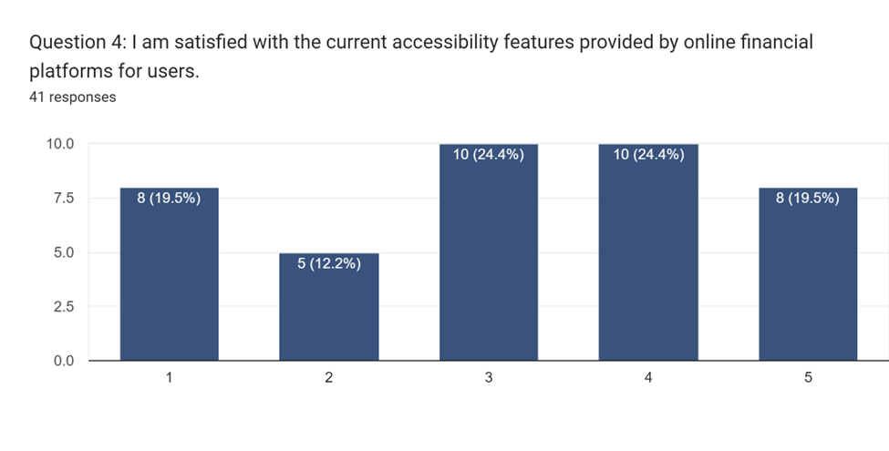

Figure 20: Survey Section B Q4 Result

Question 4 indicates a mixed sentiment regarding satisfaction with the current accessibility features of online financial platforms. Approximately 24.4% of respondents expressed neutrality with a rating of 3, while another 24.4% leaned towards satisfaction, giving a rating of 4. This suggests a need for improvement in the current accessibility landscape, as a significant portion of participants falls between neutral and satisfied. The feedback emphasizes the importance of enhancing accessibility features to better meet user expectations and needs.

**Question 5: I have encountered difficulties when accessing financial information or services online alone.**

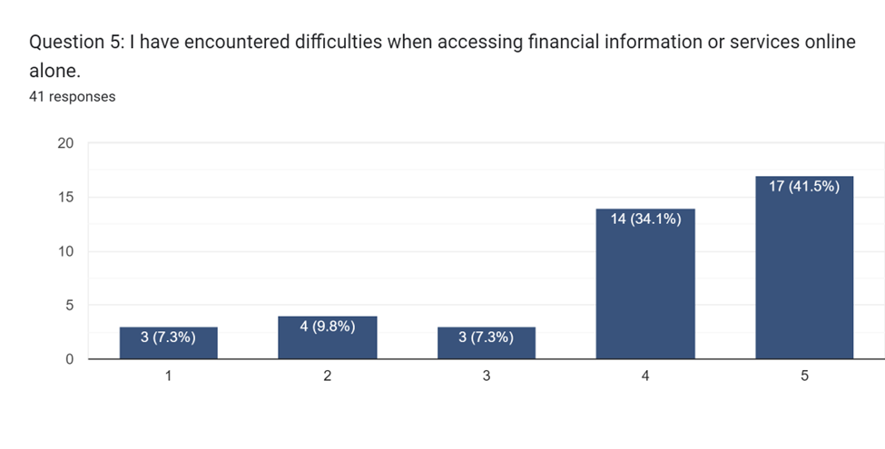

Figure 21: Survey Section B Q5 Result

Question 5 reveals that 41.5% of participants acknowledged encountering difficulties when accessing financial information or services online independently, giving a rating of 5. This suggests a notable portion of users facing challenges, indicating potential barriers in the current online financial platforms. The insights gathered highlight the significance of addressing these difficulties to enhance the overall user experience and ensure inclusivity for all users, especially those facing obstacles in independent navigation.

**Question 6: I often navigate online financial platforms using external assistive tools**

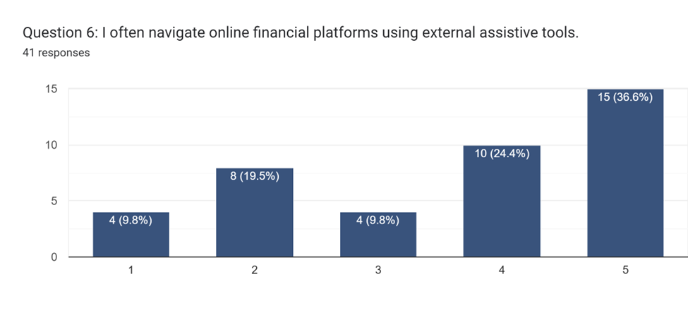

Figure 22: Survey Section B Q6 Result

In response to Question 6, 36.6% of participants indicated a frequency of 5, signifying that they often navigate online financial platforms using external assistive tools. Additionally, 19.5% of respondents provided a rating of 2, indicating a less frequent use of external assistive tools. These results shed light on the varying degrees of reliance on external tools for navigating online financial platforms, emphasizing the need for solutions that accommodate different user preferences and accessibility requirements.

**Question 7: I have experienced compatibility challenges when using external assistive tools on online financial platforms.**

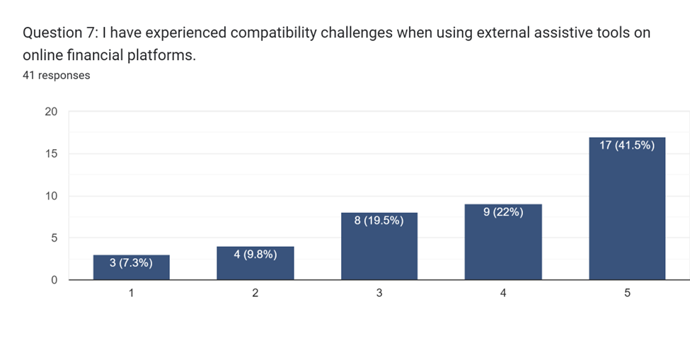

Figure 23: Survey Section B Q7 Result

Regarding question 7, 41.5% of participants reported facing compatibility challenges when using external assistive tools on online financial platforms, indicating a notable portion of respondents experiencing issues in this aspect. This underscores the importance of addressing compatibility issues to enhance the overall accessibility and user experience for individuals relying on assistive technologies. The findings suggest that improvements in compatibility between external assistive tools and online financial platforms could contribute to a more seamless and effective user interaction.

**Question 8: I have privacy concerns when using external assistive tools.**

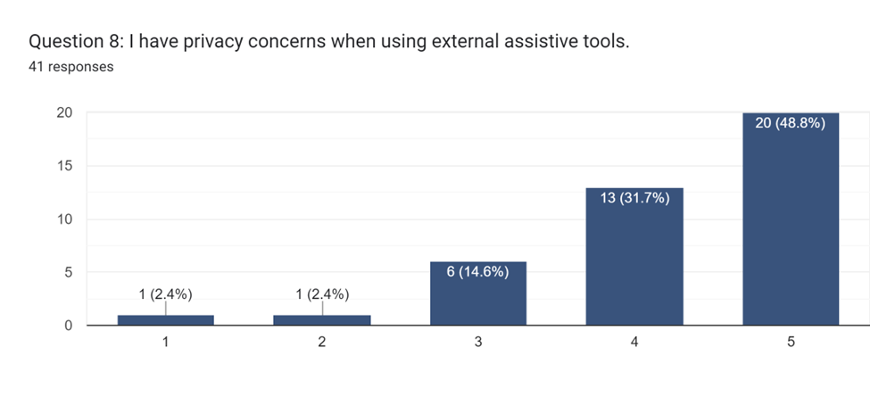

Figure 24: Survey Section B Q8 Result

In response to Question 8, 48.8% of respondents expressed privacy concerns when using external assistive tools on online financial platforms, indicating a substantial portion of participants with apprehensions in this regard. This highlights a significant aspect to consider in the development and implementation of assistive technologies for online financial services. Addressing privacy concerns becomes crucial in ensuring that users feel secure and protected while utilizing external assistive tools, emphasizing the need for robust security measures in the proposed solution.

**Question 9: I face challenges when adapting to frequent new updates of the online financial platform.**

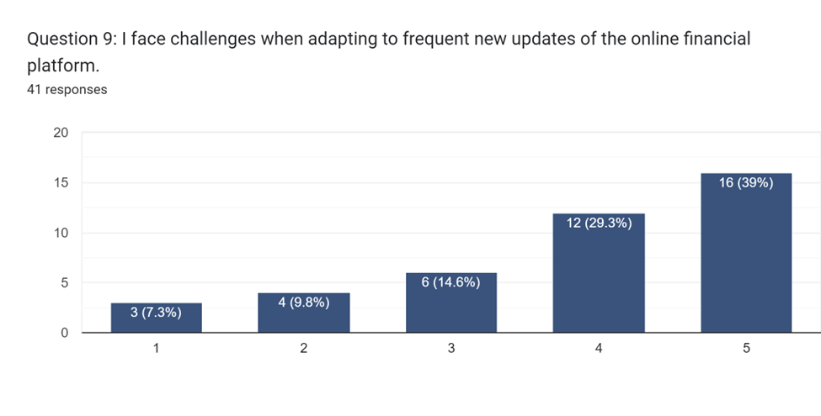

Figure 25: Survey Section B Q9 Result

The analysis of Question 9 indicates that a substantial percentage, accounting for 39% of the respondents, rated their challenges in adapting to frequent updates of online financial platforms as the highest level on the scale, 5. This suggests a notable level of difficulty and resistance among the participants in coping with the frequent changes introduced in the online financial platforms they engage with.

**Question 10: I am willing to switch to a more accessible online financial platform if available.**

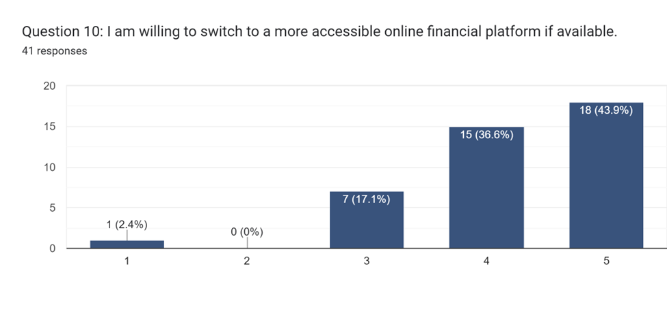

Figure 26: Survey Section B Q10 Result

The analysis of Question 10 indicates that a notable percentage, amounting to 43.9% of the participants, expressed a high willingness to switch to a more accessible online financial platform if one is available, as evidenced by their rating of 5. This finding underscores the importance of accessibility in influencing users' decisions regarding the choice of online financial platforms. It suggests that a considerable portion of users is proactive in seeking platforms that prioritize accessibility features, indicating a potential shift in user preferences towards platforms that cater to their specific needs for enhanced accessibility.

**Question 11: I have a positive perception of adapting internal assistive technologies built into online financial platforms.**

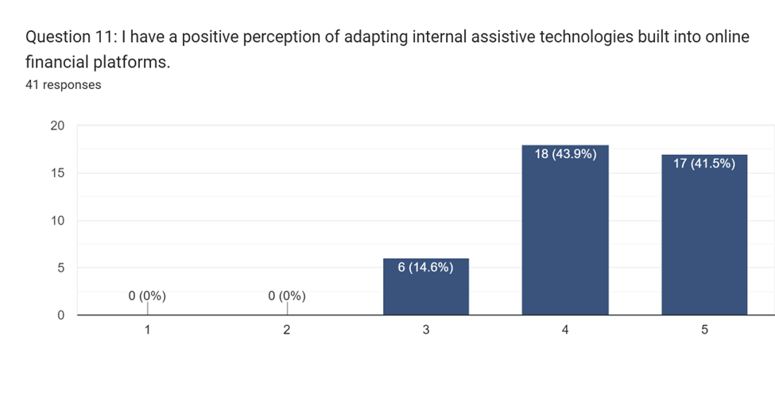

Figure 27: Survey Section B Q11 Result

The analysis of Question 11 indicates that a substantial portion, specifically 43.9% of participants, holds a positive perception of adapting internal assistive technologies built into online financial platforms, as reflected in their rating of 4. This finding suggests that there is a notable acceptance and favorable view among users regarding the integration of internal assistive technologies within the platforms themselves. Respondents seem receptive to the idea of built-in solutions that enhance accessibility, potentially leading to a more seamless and user-friendly experience.

**Question 12: I agree that technology like FinEase can contribute to achieving SDG 10.**

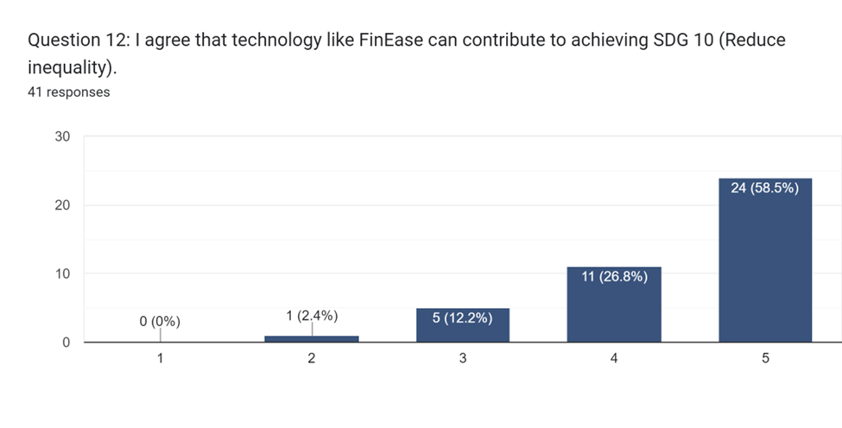

Figure 28: Survey Section B Q12 Result

The analysis of Question 12 highlights a strong consensus among participants, with 58.5% expressing a robust agreement that technology like FinEase can significantly contribute to achieving Sustainable Development Goal (SDG) 10. This positive response indicates a widespread belief in the potential of FinEase, emphasizing its perceived impact on reducing inequality. The alignment of user perceptions with broader societal goals underscores the significance of FinEase's role in promoting financial inclusivity. As a result, the findings suggest that such technological initiatives are well-received and considered instrumental in addressing broader social challenges.

**Question 13: I am confident that the adoption of FinEase can significantly improve financial inclusivity.**

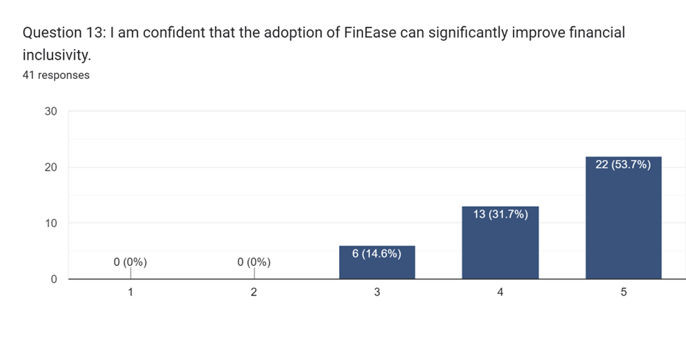

Figure 29: Survey Section B Q13 Result

The analysis of Question 13 indicates a high level of confidence among participants, with 53.7% expressing strong agreement regarding the adoption of FinEase and its potential to significantly improve financial inclusivity. This positive response underscores a prevailing optimism among users regarding the efficacy of FinEase in fostering a more inclusive financial landscape. The confidence expressed by participants reflects a belief in the transformative impact of technology, reinforcing the notion that initiatives like FinEase can serve as catalysts for positive change within the realm of financial accessibility.

**Question 14: What do you consider the most significant challenges in accessing financial information online today?**

Based on the survey results, the summarized data highlights the challenges that emphasize the importance of developing inclusive and accessible online financial platforms. These challenges pertain to issues related to both usability and security for visually impaired users.

1. **Limited Accessibility Features**: Visually impaired individuals face challenges accessing financial information due to insufficient accessibility features on websites. Key issues include the absence of screen reader compatibility and difficulties in navigating interfaces designed primarily for visual users.
2. **Security and Privacy Concerns**: The fear of cybersecurity threats and scams is a significant barrier. Users express concerns about weak passwords, potential fraud, and privacy issues when relying on online platforms to access financial information.
3. **Educational Barriers**: Limited financial literacy poses a hurdle, as navigating complex financial information often requires specialized knowledge. The lack of user-friendly guidelines makes it challenging for individuals without formal finance education to comprehend and utilize online financial resources effectively.
4. **Unfriendly User Interfaces**: Some financial platforms present unfriendly user interfaces, featuring small text that is challenging for visually impaired users to read. The difficulty in adapting to constant changes in the user interface further complicates the user experience.
5. **Dependency on Others**: Visually impaired individuals often rely on others for interpretation or assistance in accessing financial information online. This dependency raises privacy concerns and highlights the need for more user-friendly and independent accessibility features.

**Question 15: What specific accessibility features do you believe are most crucial for online financial platforms to have for users with visual impairments?**

According to the survey results, the specific accessibility features deemed crucial for online financial platforms to accommodate users with visual impairments include:

1. **Text-to-Speech Functionality**: Enabling text-to-speech features helps users by audibly conveying financial information, facilitating comprehension through spoken content.
2. **Screen Reader Compatibility**: Ensuring compatibility with screen readers enhances accessibility, allowing visually impaired users to navigate and interact with the platform effectively.
3. **User-Friendly Interface Design**: Implementing a user interface that avoids relying on color alone for conveying information is vital. Additionally, considering font style, size, and color contrast caters to various visual impairments, enhancing user engagement.
4. **Hot Keys and Shortcut Keys**: Providing hot keys for easier access to features enhances efficiency in navigating the platform, allowing users to perform actions more quickly.
5. **Guided Navigation and Customization**: Offering guided navigation, webpage customization, and selective reading options contribute to a more tailored and user-friendly experience. This includes proper descriptions for images, PDFs, graphs, and charts, as well as high contrasts and large text for improved visibility.

## 3.5 Summary

The methodology section thoroughly explains the idea of System Development Methods as organized structures that direct information system development. The reasoning for choosing the Scrum framework within the Agile methodology over the Waterfall model is elaborated, highlighting Scrum's adaptability, ongoing client collaboration, and iterative development to match with the project's dynamic characteristics. The survey methodology is employed for data collection, ensuring effectiveness in gathering varied viewpoints and quantitative data on user preferences. The ensuing data analysis offers insights into participant demographics and showcases important discoveries from the Likert-scale queries, providing understanding of user awareness, preferences, obstacles, and perceptions. Prominent patterns encompass a firm belief in giving importance to accessibility enhancements, an inclination towards autonomous financial management, and concerns about privacy when utilizing external assistive tools. Ultimately​ examining the open-ended questions reveals significant challenges and essential accessibility features critical for shaping the project's direction.

# Chapter 4: Design and Implementation

## 4.1 Introduction

technology

## 4.2 System Design

### 4.2.1 Use Case Diagram

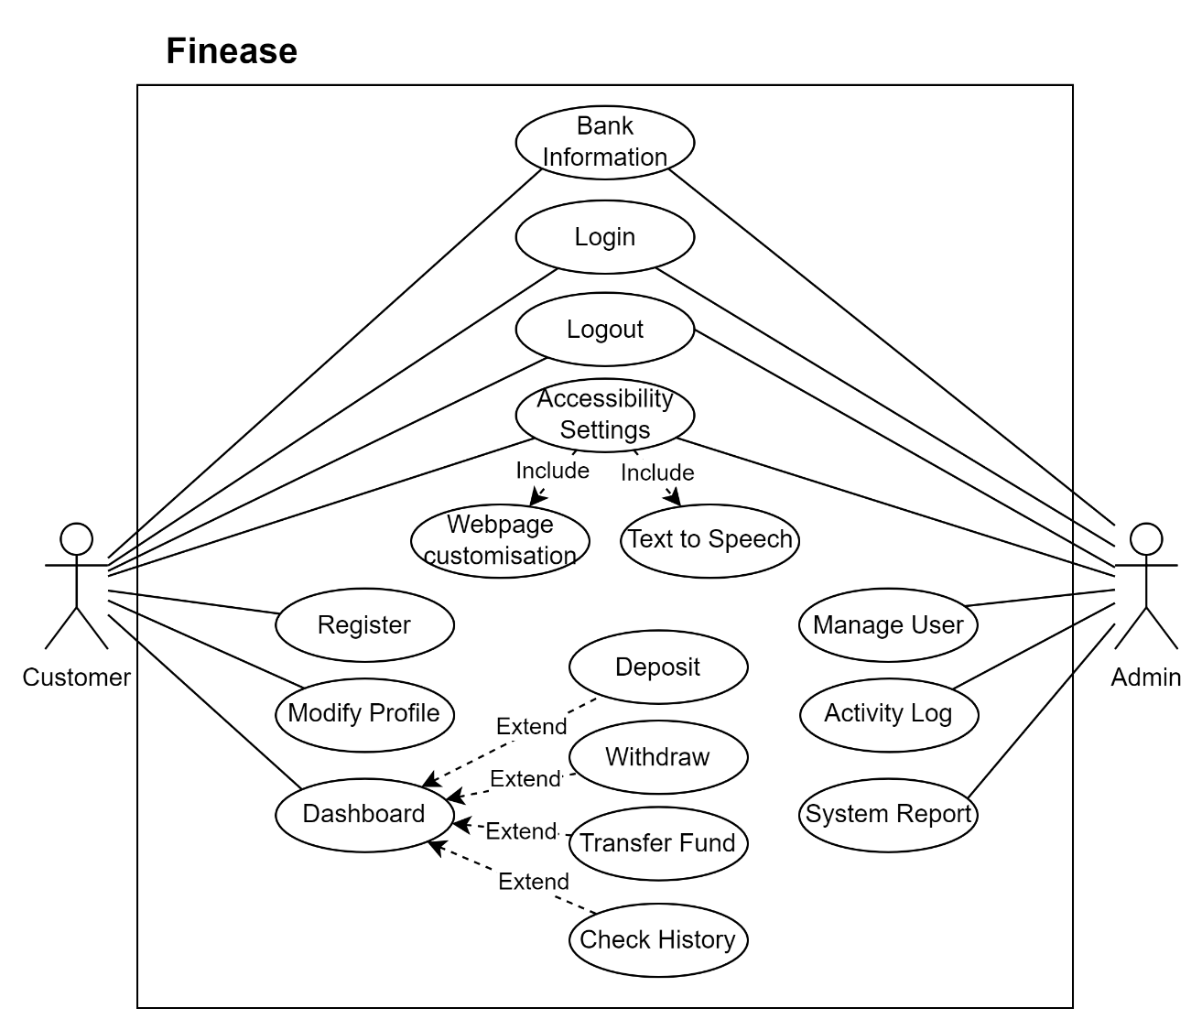

The system focuses on the customize webpage and text to speech feature

#### 4.2.1.1 Use Case Specification – Bank Information

|  |  |
| --- | --- |
| **Use Case Name** | Text |
| **Actor(s)** |  |
| **Description** |  |
| **Priority** |  |
| **Precondition(s)** |  |
| **Main Flow** |  |
| **Alternative Flow** |  |
| **Postcondition(s)** |  |

#### 4.2.1.1 Use Case Specification - Register

|  |  |
| --- | --- |
| **Use Case Name** | Text |
| **Actor(s)** |  |
| **Description** |  |
| **Priority** |  |
| **Precondition(s)** |  |
| **Main Flow** |  |
| **Alternative Flow** |  |
| **Postcondition(s)** |  |

Use case specification

### 4.2.2 Activity Diagrams

#### 4.2.2.1 Bank Information

#### 4.2.2.2 Register

Next. 4.3 Database Design (If needed)

## 4.3 Interface Design

technology

## 4.4 Execution

technology

## 4.5 Screenshot

technology

## 4.6 Summary

technology

# Chapter 5: Result and Discussion

## 5.1 Introduction

technology

## 5.2 Testing Design/ Plan

technology

## 5.3 System Testing and Discussion

technology

## 6.4 Summary

technology

# Chapter 6: Conclusion

## 6.1 Critical Evaluation

*In conclusion, this project aims to address a pressing issue in today's digital world by focusing on improving financial accessibility for people with visual impairments. By integrating Text-to-Speech technology into online financial platforms, the project seeks to empower users to manage their finances independently and effectively. The survey findings, combined with thorough domain research, form the basis of a solution that aligns with Sustainable Development Goal 10 – reducing inequality. The proposed system, called FinEase, strives to bridge the accessibility gap and offer concrete benefits such as enhanced financial inclusion, efficiency, and compliance with accessibility regulations. The culmination of research, analysis,and strategic planning positions FinEase as an encouraging initiative aimed at creating a more inclusive financial environment.*

## 6.2 Limitation

*Despite the project's ambitious goals, it is important to recognize certain constraints. One main limitation is the reliance on existing technologies and compatibility requirements. The success of FinEase depends on seamless integration with widely used web browsers and assistive technologies. Additionally, meeting industry standards and data security regulations poses challenges in balancing accessibility needs with strict security measures. The scalability of the system must also be considered to accommodate future improvements and increasing user demands. Furthermore, the project's scope does not include a complete overhaul of the entire online banking platform; instead, it focuses solely on accessibility-related enhancements. Acknowledging these limitations is essential for managing expectations and refining the system in future iterations.*

## 6.3 Recommendation

*The process of conceptualizing and planning for the implementation of FinEase has been eye-opening, revealing the complex interaction between technology, accessibility, and user-centered design. Navigating through the obstacles faced by visually impaired individuals in accessing online financial services underscored the necessity for a solution that not only tackles technical aspects but also embraces inclusivity. Additionally, the survey conducted to comprehend user preferences and challenges served as a valuable feedback mechanism, guiding the research process. Moving forward, reflecting on this journey highlights the importance of flexibility, collaboration with advocacy groups, and an unwavering commitment to creating technology that caters to diverse needs within the digital realm. FinEase serves as evidence showing how technology can overcome barriers and promote a more inclusive and accessible future.*

# References

Ahmed, T., Hoyle, R., Connelly, K., Crandall, D., & Kapadia, A. (2015). Privacy Concerns and Behaviors of People with Visual Impairments. *Proceedings of the 33rd Annual ACM Conference on Human Factors in Computing Systems*. https://doi.org/10.1145/2702123.2702334

AWS. (n.d.). *What is Java? - Enterprise Java Beginner’s Guide - AWS*. Amazon Web Services, Inc. https://aws.amazon.com/what-is/java/

Babu, R., & Singh, R. (2009). *Association for Information Systems AIS Electronic Library (AISeL) Understanding Blind Users’ Accessibility and Usability Problems in an Online Task Recommended Citation*. https://aisel.aisnet.org/cgi/viewcontent.cgi?article=1266&context=amcis2009

Bank of America. (n.d.). *Web Accessibility | Accessible Banking with Bank of America*. Bank of America. https://www.bankofamerica.com/accessible-banking/web-access/

Barclays. (n.d.). *Accessibility and disability*. Www.barclays.co.uk. https://www.barclays.co.uk/accessibility/

BBC. (n.d.). *Accessibility*. Www.bbc.co.uk. https://www.bbc.co.uk/accessibility/

Computer Hope. (2019). *What is Windows?* Computerhope.com. https://www.computerhope.com/jargon/w/windows.htm

Corbo, A. (2022). *What Is Python? (Definition, Uses, Difficulty) | Built In*. Builtin.com. https://builtin.com/software-engineering-perspectives/python

Dosono, B., Hayes, J., & Wang, Y. (2018). Toward Accessible Authentication: Learning from People with Visual Impairments. *IEEE Internet Computing*, *22*(2), 62–70. https://doi.org/10.1109/mic.2018.112101619

Fatima, K., Bawany, N. Z., & Bukhari, M. (2020, October 1). *Usability and Accessibility Evaluation of Banking Websites*. IEEE Xplore. https://doi.org/10.1109/ICACSIS51025.2020.9263083

Gangadharan, S. P. (2015). The downside of digital inclusion: Expectations and experiences of privacy and surveillance among marginal Internet users. *New Media & Society*, *19*(4), 597–615. https://doi.org/10.1177/1461444815614053

Garfinkel, S., & Lipford, H. R. (2014). Usable Security: History, Themes, and Challenges. *Synthesis Lectures on Information Security, Privacy, and Trust*, *5*(2), 1–124. https://doi.org/10.2200/s00594ed1v01y201408spt011

Guerreiro, J., & Gonçalves, D. (2014). Text-to-speeches: evaluating the perception of concurrent speech by blind people. *Proceedings of the 16th International ACM SIGACCESS Conference on Computers & Accessibility - ASSETS ’14*, 169–176. https://doi.org/10.1145/2661334.2661367

Hussain, A., & Mohamed Omar, A. (2020). Usability Evaluation Model for Mobile Visually Impaired Applications. *International Journal of Interactive Mobile Technologies (IJIM)*, *14*(05), 95. https://doi.org/10.3991/ijim.v14i05.13349

Loshin, P., & Bigelow, S. J. (2021). *What is the Linux operating system?* SearchDataCenter. https://www.techtarget.com/searchdatacenter/definition/Linux-operating-system

MDN Contributors. (2019). *What is JavaScript?* MDN Web Docs. https://developer.mozilla.org/en-US/docs/Learn/JavaScript/First_steps/What_is_JavaScript

Napoli, D. (2018). *Accessible and Usable Security: Exploring Visually Impaired Users’ Online Security and Privacy Strategies*. https://repository.library.carleton.ca/concern/parent/rn301227c/file_sets/1544bp872

Podsiadło, M., & Chahar, S. (2016). Text-to-Speech for Individuals with Vision Loss: A User Study. *INTERSPEECH 2016*. https://doi.org/10.21437/interspeech.2016-1376

Pomponio, A. (2022). *Tomcat vs. NGINX | OpenLogic by Perforce*. Www.openlogic.com. https://www.openlogic.com/blog/tomcat-vs-nginx

Raja, D. S. (2016). Digital Dividends Bridging the Disability Divide through Digital Technologies. In *The World Bank*. https://thedocs.worldbank.org/en/doc/123481461249337484-0050022016/original/WDR16BPBridgingtheDisabilityDividethroughDigitalTechnologyRAJA.pdf

Ramakrishnan, I. V., Ashok, V., & Billah, S. M. (2017). Non-visual Web Browsing: Beyond Web Accessibility. *Lecture Notes in Computer Science*, *10278*. https://doi.org/10.1007/978-3-319-58703-5_24

Ramakrishnan, I., Ashok, V., & Billah, S. M. (2017). *Non-visual Web Browsing: Beyond Web Accessibility*. https://doi.org/10.1007/978-3-319-58703-5_24

Ronchi, C., Khodjanov, A., Mahkamov, M., & Zakhidov, S. (2011). Security, Privacy and Efficiency of Internet Banking Transactions. *World Congress on Internet Security (WorldCIS-2011)*. https://doi.org/10.1109/WorldCIS17046.2011.5749854

Saravanan, K. (2017). SYSTEMS DEVELOPMENT METHODOLOGIES: CONCEPTUAL STUDY. *Indian J.Sci.Res*, *14*(1), 27–37. https://www.ijsr.in/upload/105047310905.pdf

Scanlan, M. (2021). Reassessing the disability divide: unequal access as the world is pushed online. *Universal Access in the Information Society*, *21*, 725–735. https://doi.org/10.1007/s10209-021-00803-5

Schnell, K., & Roy, K. (2021). Website Privacy Notification for the Visually Impaired. *2021 IEEE Symposium Series on Computational Intelligence (SSCI)*. https://doi.org/10.1109/ssci50451.2021.9659986

Sergeev, A. (2020). What is Scrum Lifecycle. *Hygger: Project Management Software & Tools for Companies*. https://hygger.io/blog/what-is-scrum-lifecycle/

Swain, D., & Sahoo, S. S. (2021). Empowering the Visually Impaired Learners with Text-to-Speech-Based Solution. *Advances in Intelligent Systems and Computing Book Series*, *1311*, 565–573. https://link.springer.com/chapter/10.1007/978-981-33-4859-2_55

Szarkowska, A. (2011). Text-to-speech audio description: towards wider availability of AD. *The Journal of Specialised Translation,* *15*, 142–163. https://www.researchgate.net/publication/245022819_Text-to-speech_audio_description_towards_wider_availability_of_AD

Valeria, K. (2023). *Usage Share of Web Browsers*. Gloria Themes. https://gloriathemes.com/usage-share-of-web-browsers/

vpadmin. (2023). *Agile Methodology: Embracing Flexibility, Collaboration, and Continuous Improvement for Effective Project Management*. Visual Paradigm Guides. https://guides.visual-paradigm.com/agile-methodology-embracing-flexibility-collaboration-and-continuous-improvement-for-effective-project-management/

Wentz, B., Pham, D., Feaser, E., Smith, D., Smith, J., & Wilson, A. (2018). Documenting the accessibility of 100 US bank and finance websites. *Universal Access in the Information Society*, *18*(4), 871–880. https://doi.org/10.1007/s10209-018-0616-6

Wentz, B., Pham, J., & Tressler, K. (2017). Exploring the accessibility of banking and finance systems for blind users. *First Monday*, *22*(3). https://doi.org/10.5210/fm.v22i3.7036

# Appendices

## Appendix A – PPF

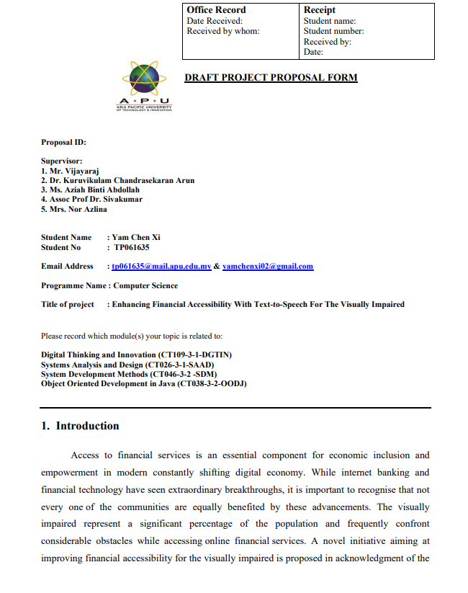

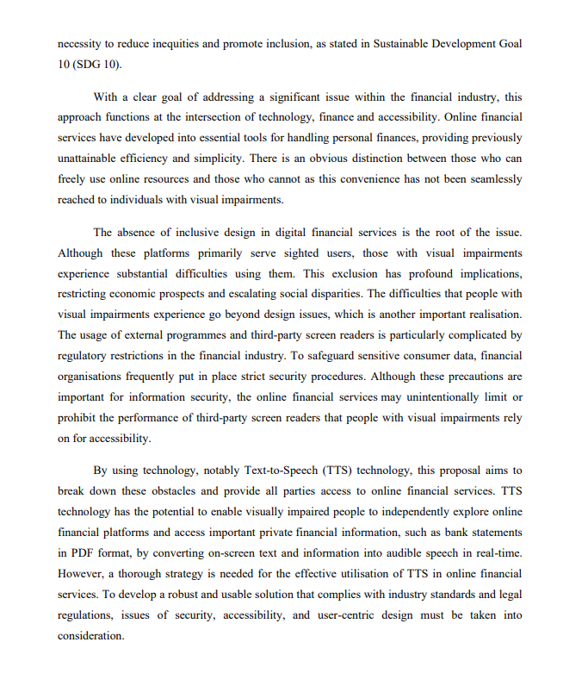

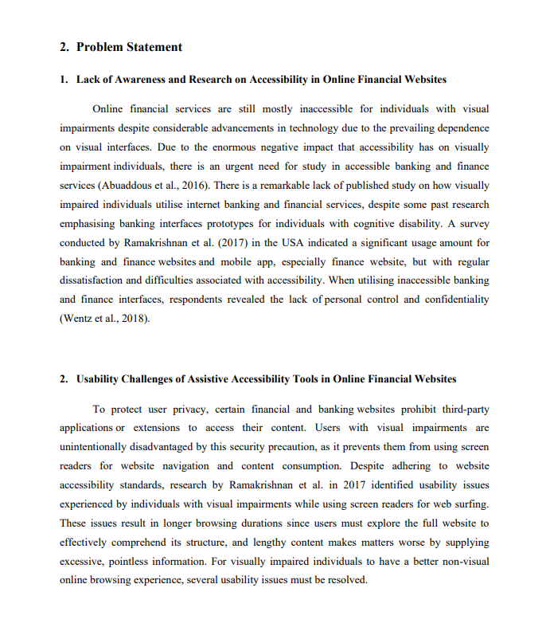

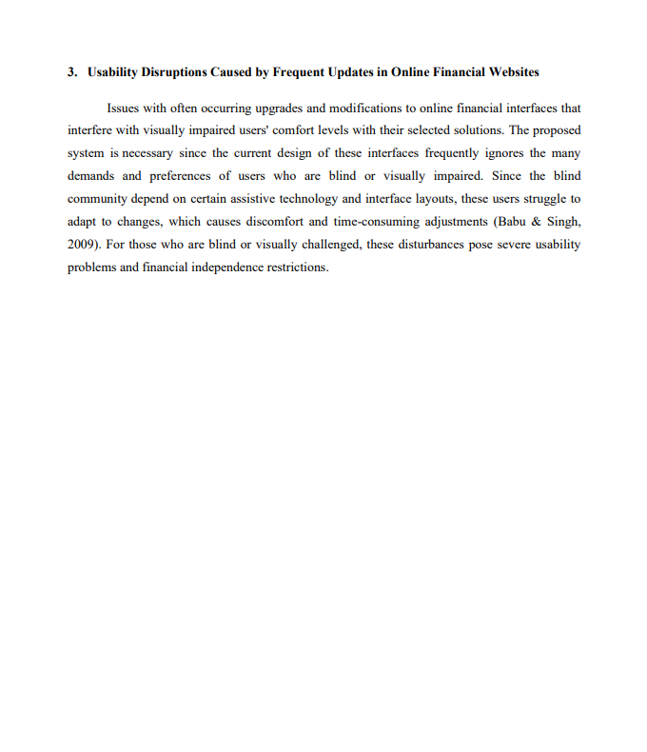

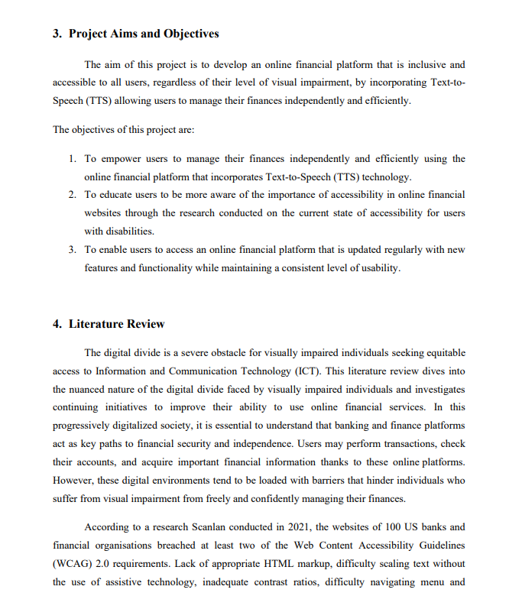

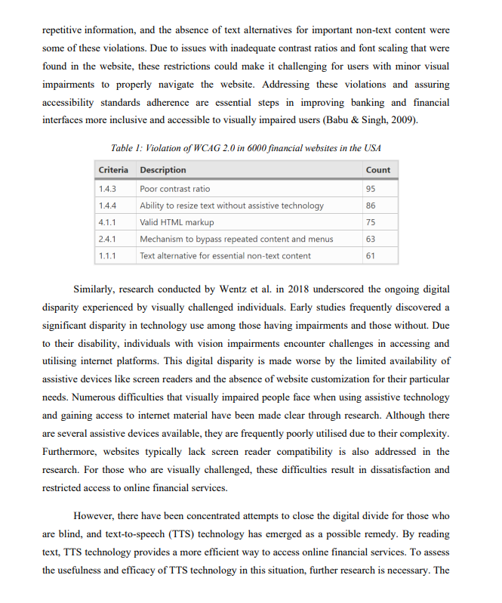

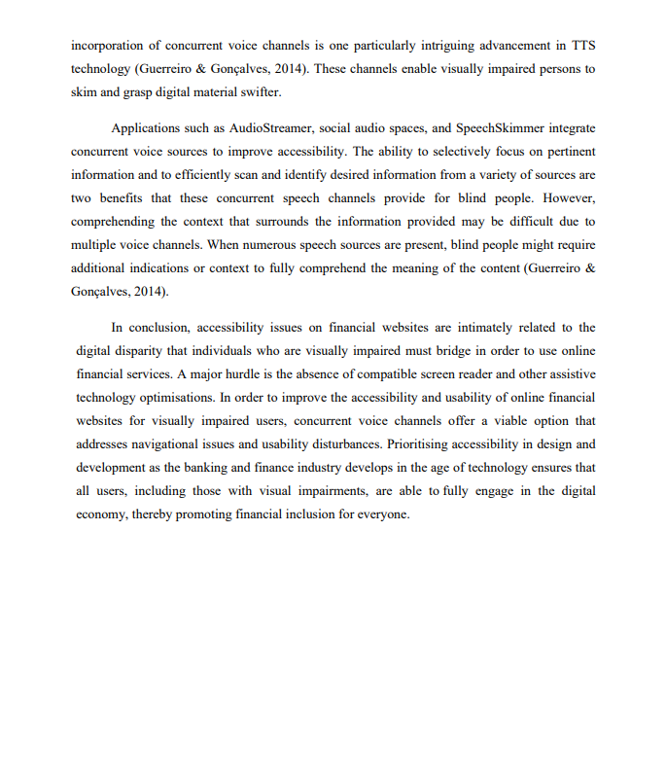

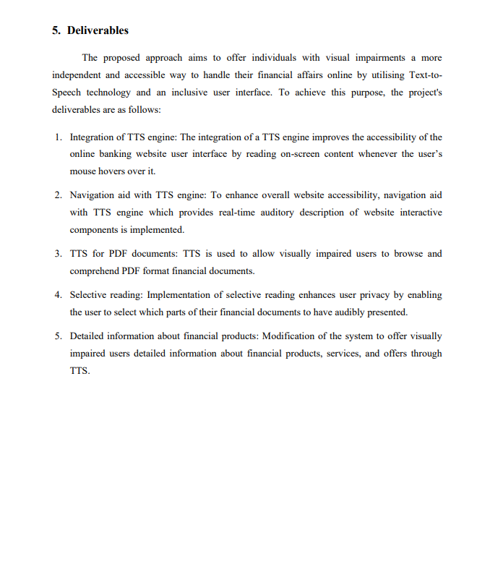

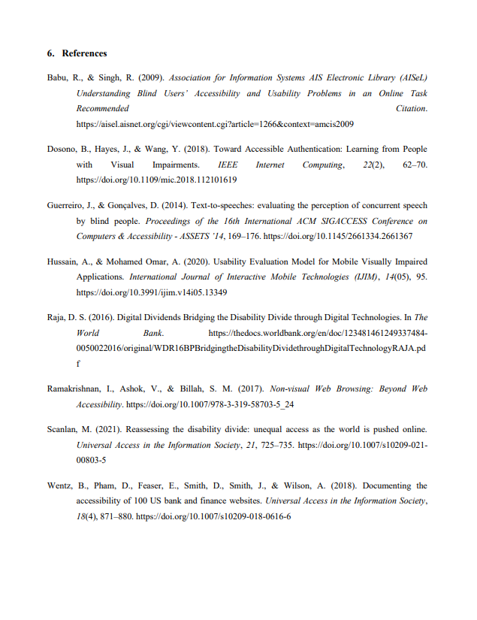

## Appendix B – Ethics Form

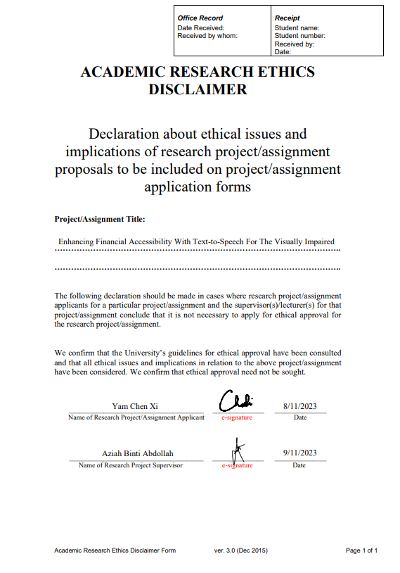

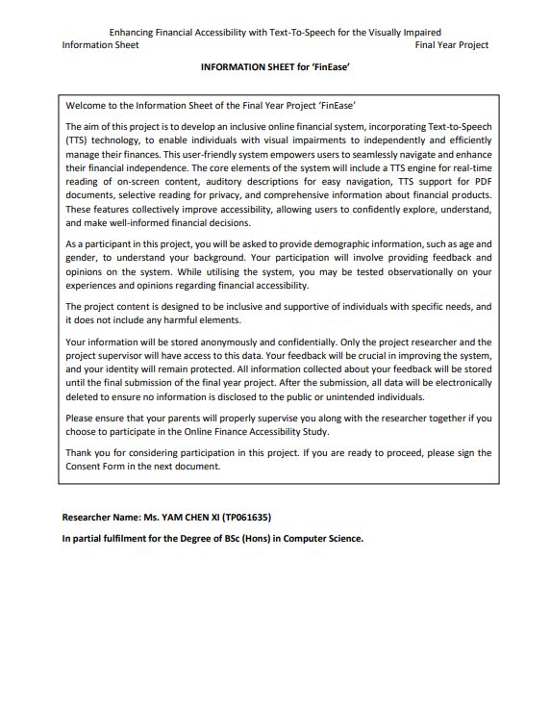

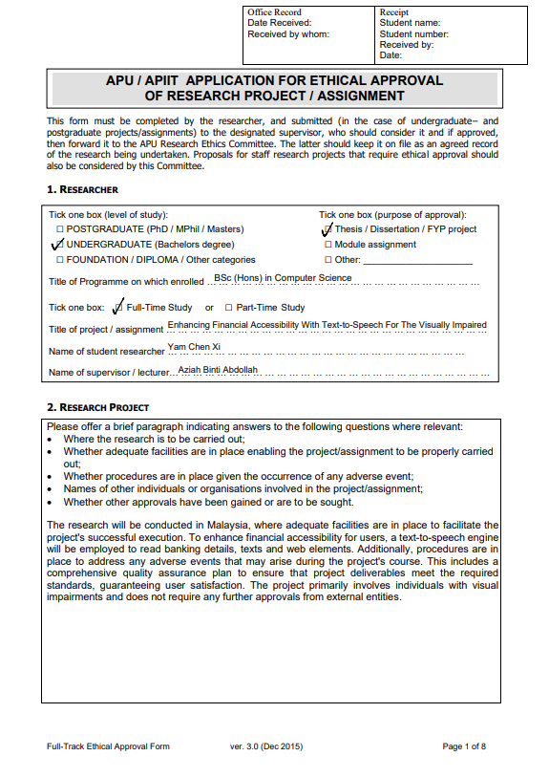

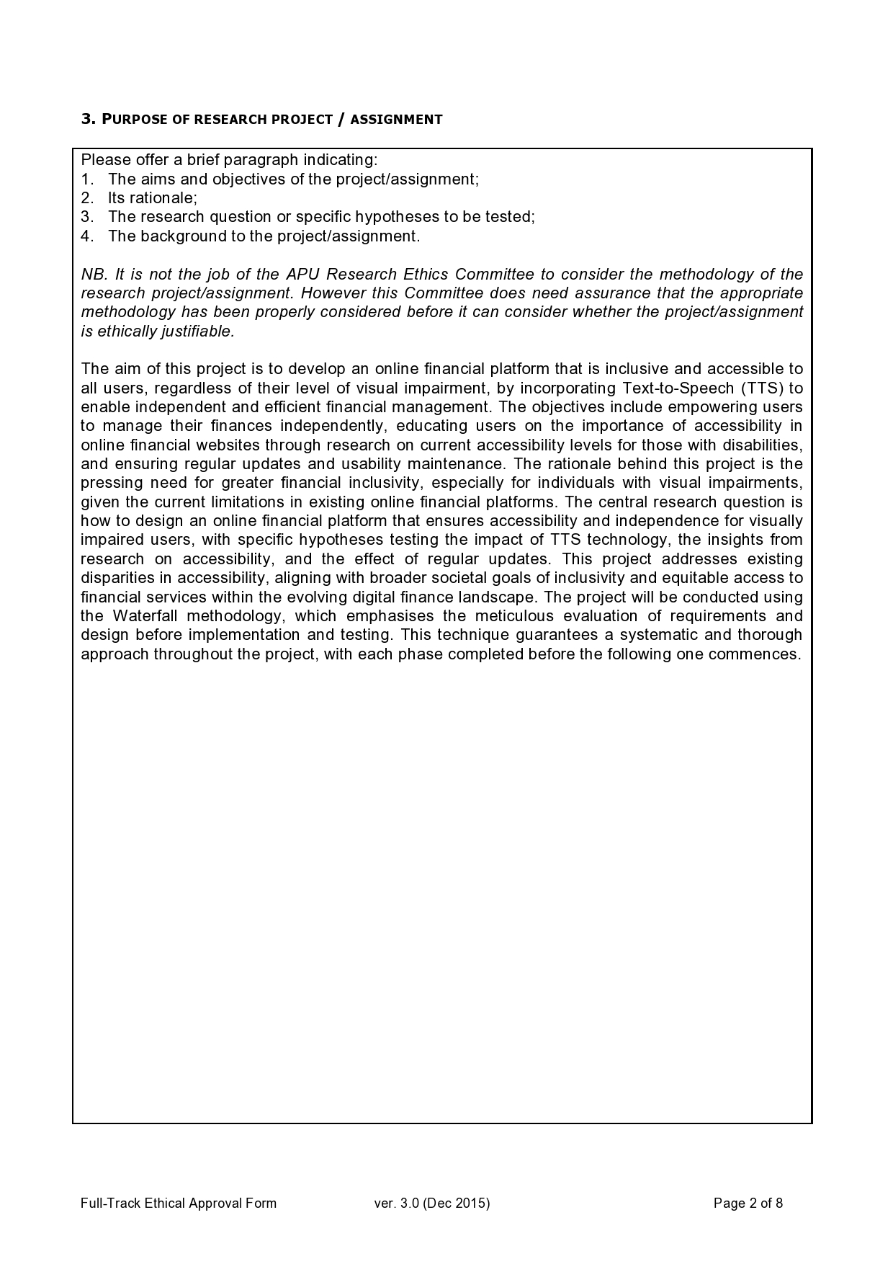

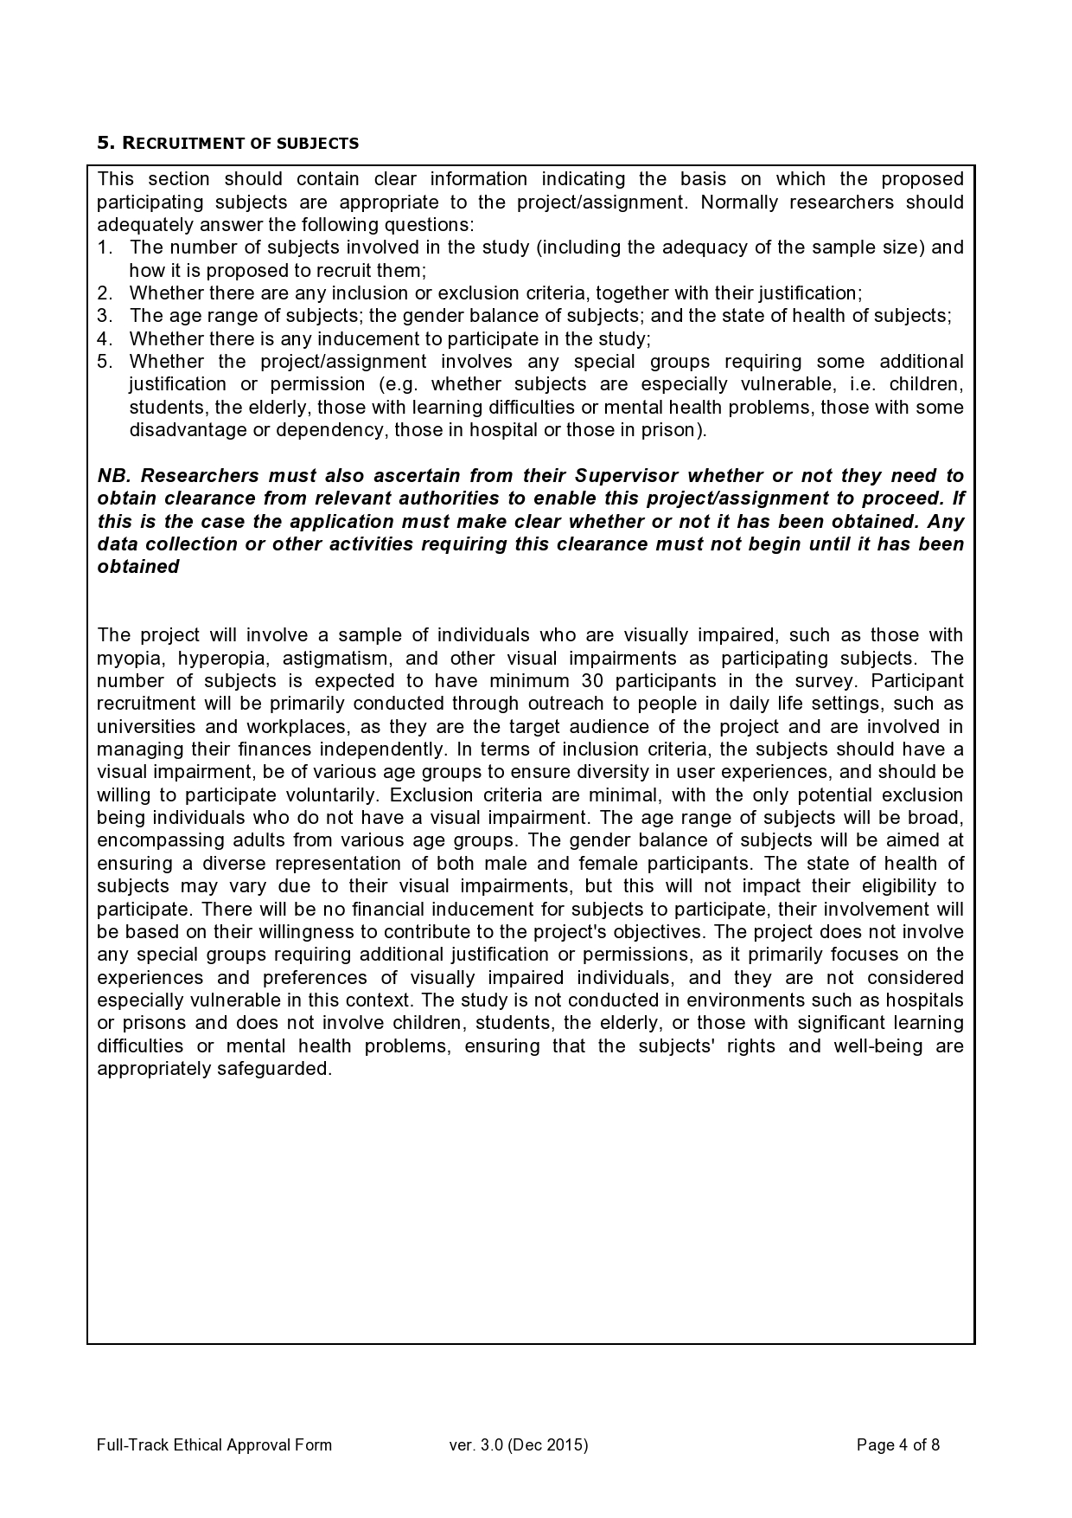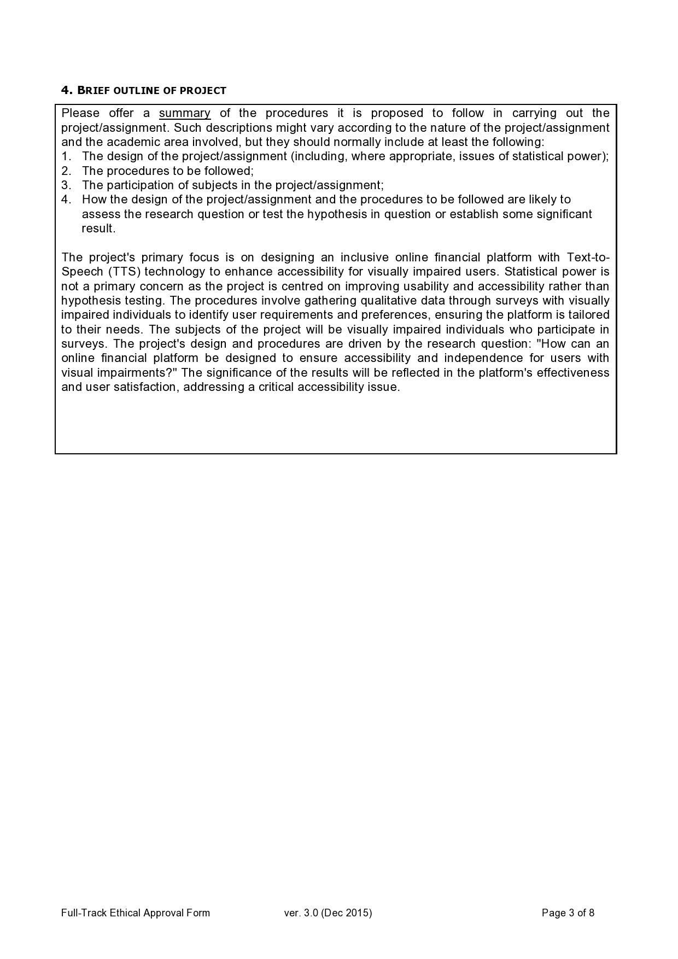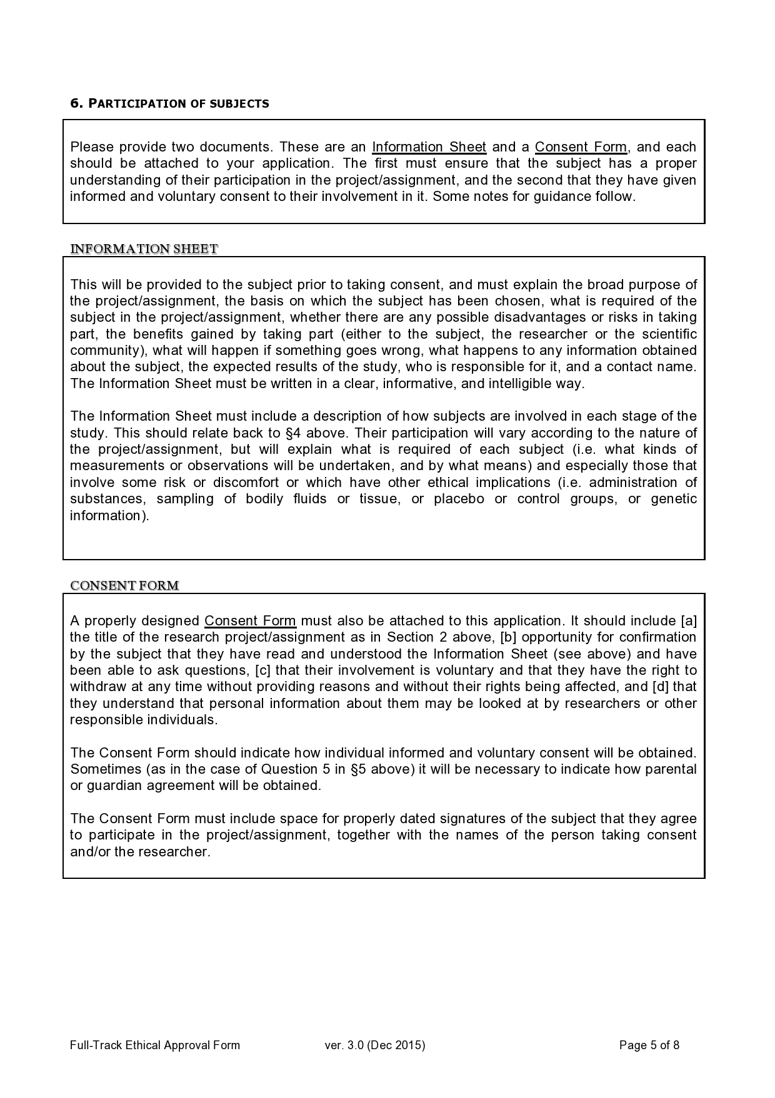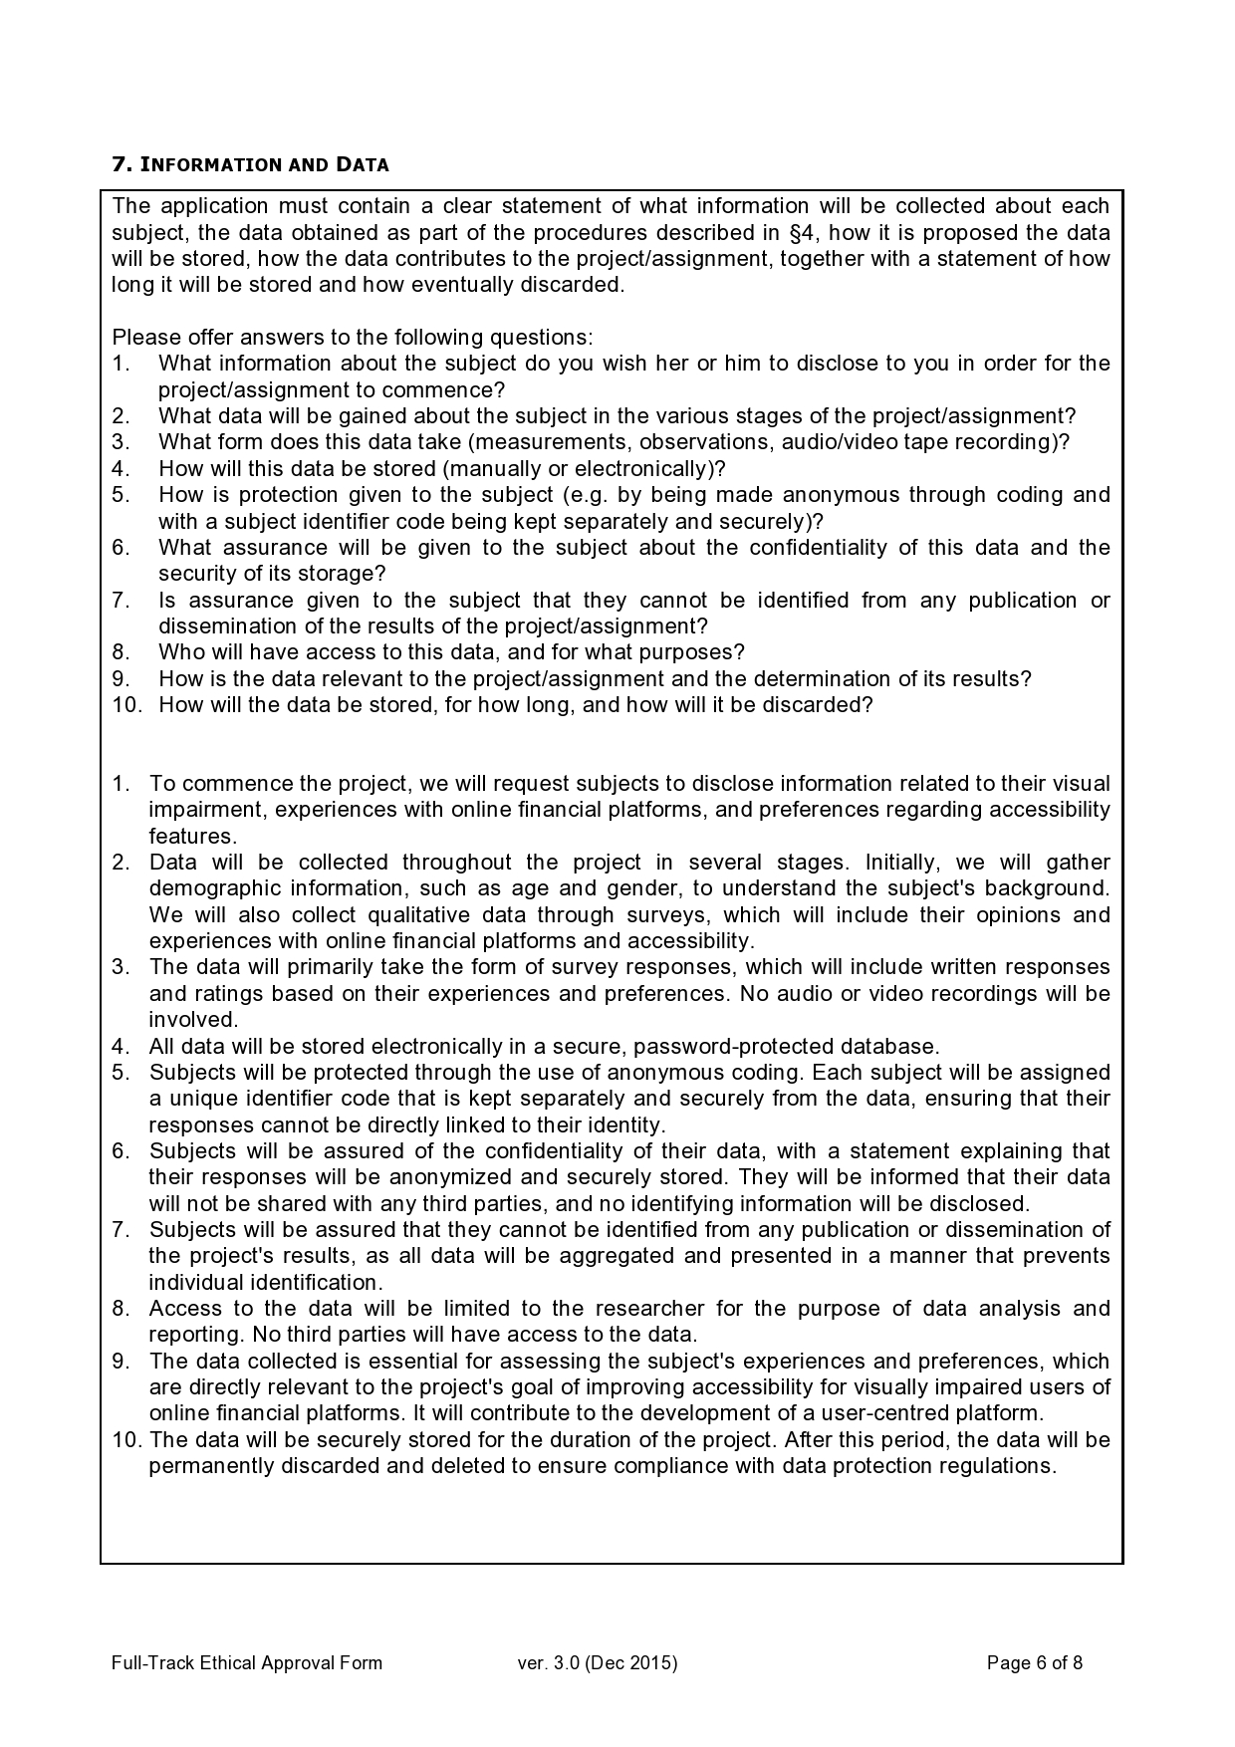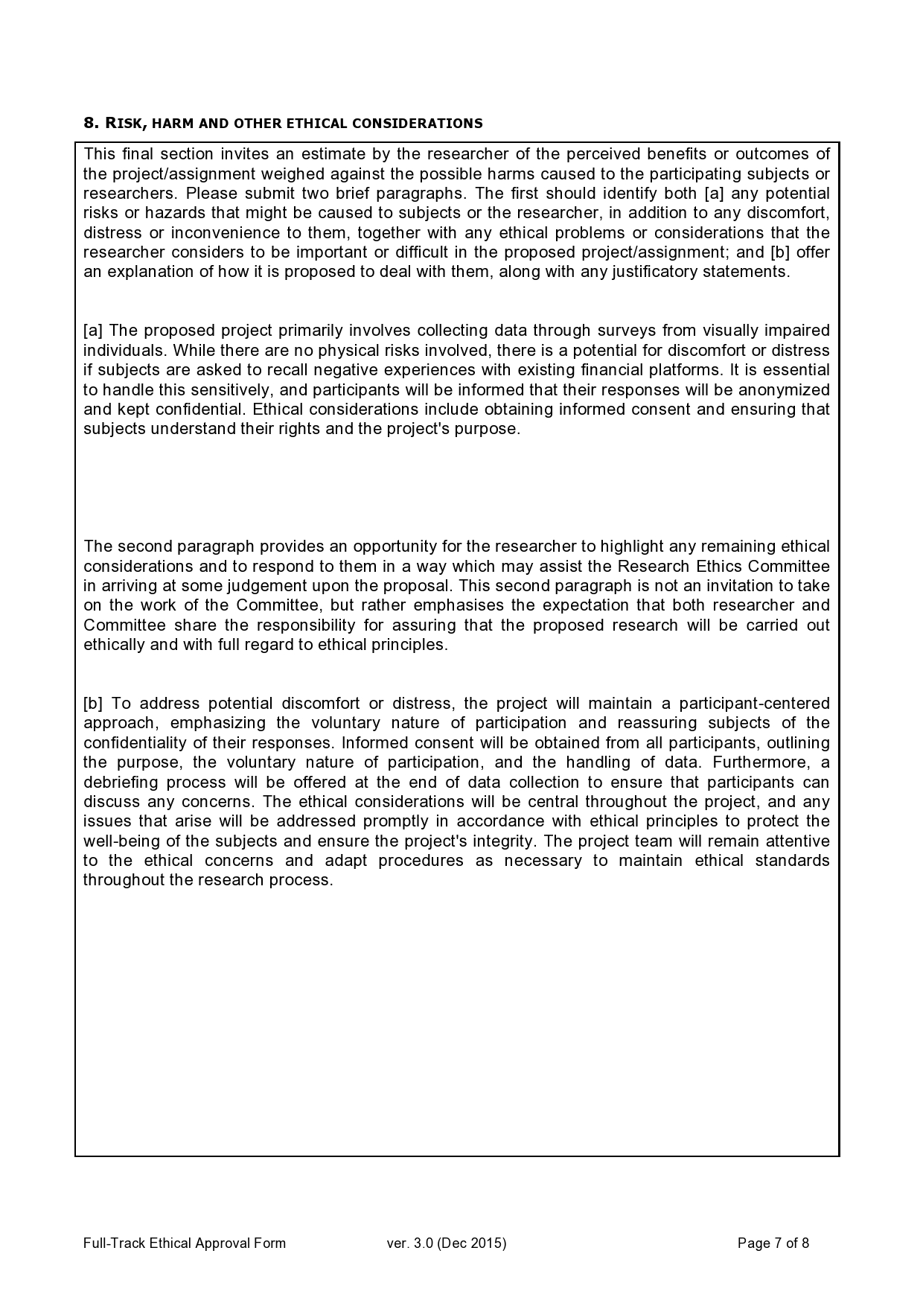

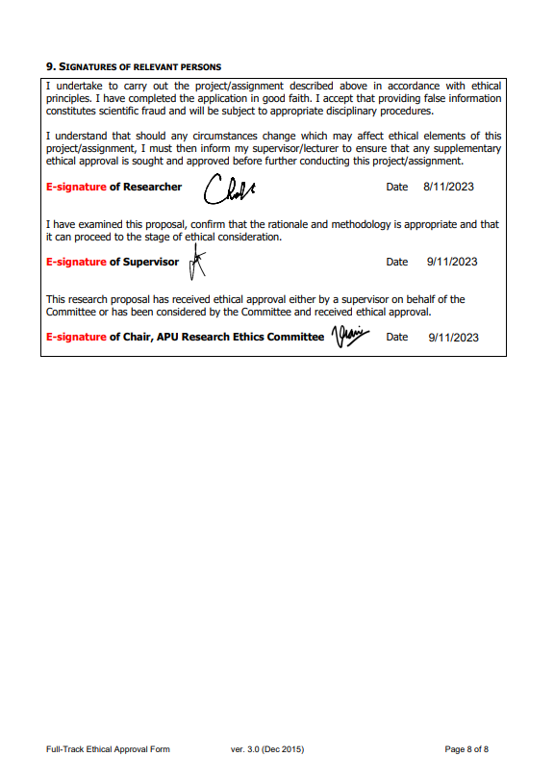

## Appendix C – Log Sheets

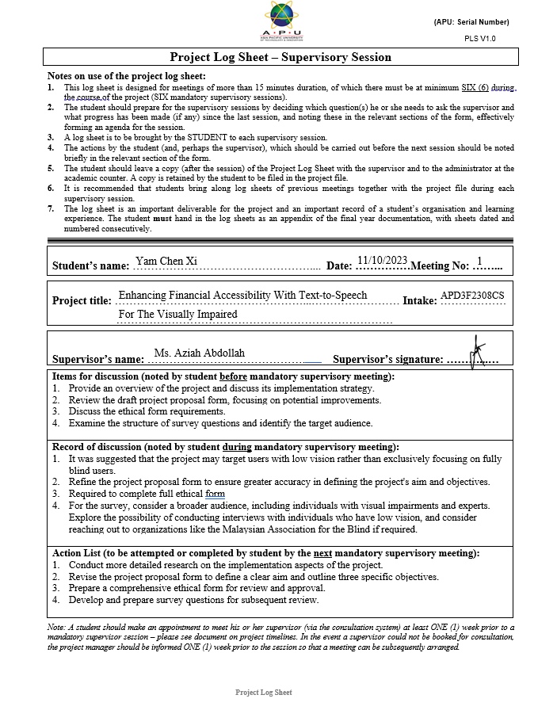

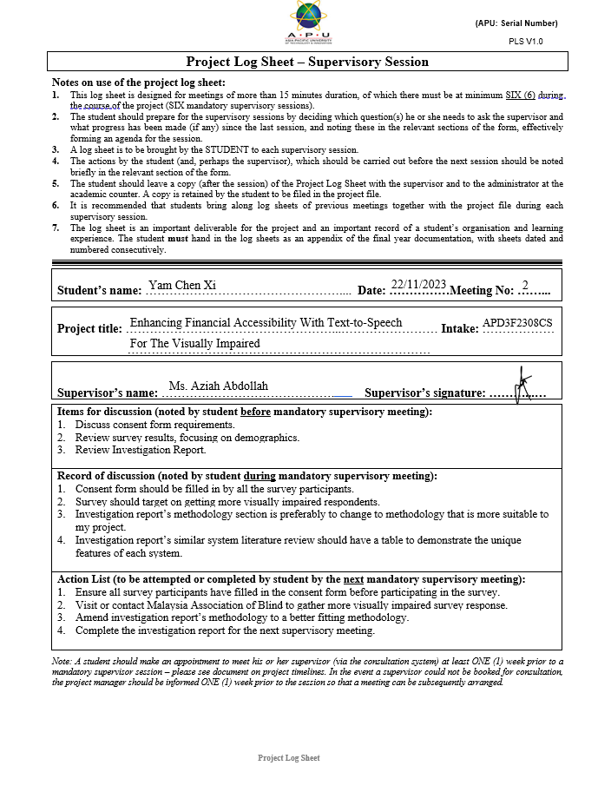

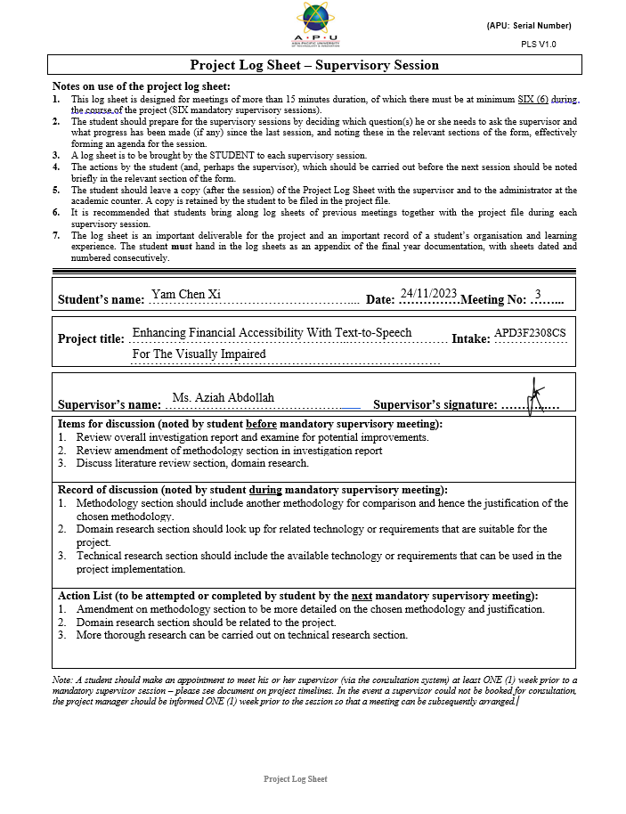

ATTACH 6 LOG SHEETS

## Appendix D – Poster

ATTACH POSTER

## Appendix E – Gantt Chart

ATTACH GANTT CHART

Include IR

## Appendix F – Sample Code Implementation

ATTACH CODE

Core functions only

## Appendix G – Respondence Demographic Profile

|  |  |  |  |  |  |
| --- | --- | --- | --- | --- | --- |
| **Participant Name** | **Age** | **Gender** | **Current Education Level** | **Employment Status** | **Vision Condition** |
| Adelia Safina | 33 | Female | Tertiary education | Employee | Blind |
| Muhammad Firdaus | 37 | Male | Others | Employee | Visually impaired |
| Liew Zheng Kee | 26 | Male | Others | Student | Visually impaired |